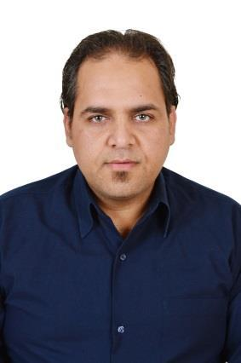
Curriculum Vitae

Name: Sayed
Address: Dubai. Deira

Email: Sayed.381428@2freemail.com

Personal Information:

Date of birth: 15 Aug. 1980

Nationality: Egyptian.

Visa Status: Visit Visa

Marital status: Married

Objective:

Seeking a suitable position in the business field in a well-known institution that measures up my qualifications.

Education:

Graduated 2002

Bachelor Degree of Technology Development.

Courses:
- Fine tuning

- Perfect pitch

- ICDL

Work Experience:

COMPANY : Genena Mall
DESIGNATION: Security
YEAR : 2003 -2006

Duties and Responsibilities:

- Responsible to conduct exterior and interior patrols of the hotel premises on a regular basis each day.

- Fill the security log with the small reports of the areas they have checked.

- Keeping a track of all the cameras installed in the Mall premises and report if there is any suspicion.

- Monitor the alarms and make arrangement for evacuation in case of emergency.

- They should maintain security station with a proper information database and stay connected with the security room so that quick actions can be taken at times of emergency.

- Maintained visible security presence to deter shoplifting and other criminal activity.

COMPANY : JW MArriott
DESIGNATION: Security Guard
YEAR : 2006 – 2017

Duties and Responsibilities:
- Answer alarms and investigate disturbances.

- Patrol industrial and commercial premises to prevent and detect signs of intrusion and ensure security of doors, windows, and gates.

- Write reports of daily activities and irregularities, such as equipment or property damage, theft, presence of unauthorized persons, or unusual occurrences.

- Monitor and authorize entrance and departure of employees, visitors, and other persons to guard against theft and maintain security of premises.

- Inspect and adjust security systems, equipment, and machinery to ensure operational use and to detect evidence of tampering.

- They are in responsibility to keep a check on the people present in the hotel and take an action if they are doubtful about someone.

- It is their responsibility to make arrangement for scanning the luggage of the guests entering the hotel so that no hazardous materials enter the hotel.

Skills:
- Languages:

- Arabic: native language

- English: Good command of written, spoken, listening.

- Computer Skills:

- Microsoft office (Word, Excel, Outlook, PowerPoint).

- Windows and Internet.

- Personal Skills:

- Interact with people from all walks of life.

- Ability to handle multiple clients.

- Recognized by ownership for strong interpersonal skills and frequently entrusted to assist top members and guests.
- Capacity to interact with people from various culture backgrounds.

- Hard worker& Can work under stress.

- Excellent team player with excellent communication skills.

Reference:

Available upon request.

