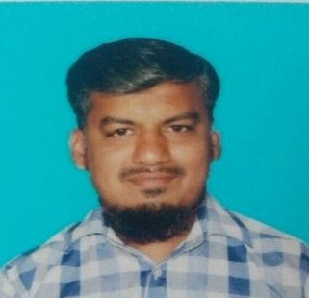
RESUME

SYED

Email: syed.381430@2freemail.com

Objective:

Seeking a Challenging position in a progressive environment that will enable me to apply my hard working and strong analytical skills to the fullest extend for the development of organization and personal growth.

Experience:

- worked as dai cuttingand box binding(super stationary l.l.c) from dubai 2014 to2016.

- Worked as folding machine operater for (varna printing press), kochin, kerala, india, from 2013 to 2014.

- Worked as binding and cutting in (deen binding press),tirunelveli, Tamil Nadu, India from 2011 to 2013.

- Worked as folding machine operater for (Rashid prinders l.l.c),dubai from 2008 to 2011.

- Worked as binding and cutting in (deen binding press),tirunelveli, Tamil Nadu, India from 2006 to 2008.

Qualification:

E.S.L.C (Secondary School Leaving Certificate)

The Muslim Higher Secondary School, Melapalayam, Tirunelveli Dt.

Computer Skills:

Operating System : Windows XP, 2000 & Windows 7

Job Responsibilities:

- Binding ,cutting , dai cutting , box binding& folding.

Languages known:

English, Hindi, Malayalam & Tamil

Pass Port Details:

Issue Date : 24th nov’2009

Expiry Date : 23th nov’2019

Place of Issue : Dubai, UAE

Visa Status : Employment Visa.

Personal Details:

D.O.B : 26-11-1981

Gender : Male

Nationality : Indian

Marital Status : Married

Declaration:

I here by declare that the above details of mine are true to the best of my knowledge.

