CURRICULUM VITAE
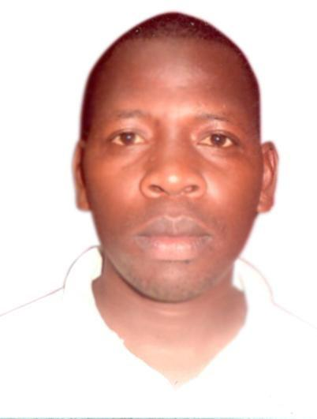

PERSONAL INFORMATION
Name | : |  | Robert
Email Address | : |  | Robert.381431@2freemail.com
Nationality | : |  | Kenyan
Marital Status | : |  | Married
Availability | : |  | Immediately
Visa Status | : |  | Visit Visa
Position | : |  | Security Guard / Customer Service.

CAREER OBJECTIVE

Seeking a challenging position where I will utilize my personal capability, skills and support my duties to the best of my capabilities and learn through new experiences in the growth of my career in ​Customer Service, Security Guard.

WORK EXPERIENCE

NOKRAS RIVERINE HOTEL AND SPA LTD

Position Held (Year 2015 – Feb 2018) : Security Guard / Customer Service Responsibilities:

- Ensuring maximum security of client assets in work station.

- Screening and monitoring guest vehicles at the entry and exit points.

- Investigations - Assist in the gathering of information relating to undesirable and criminal activities that have happened at the institution.

- Safety - Monitor and test the safety equipment to ensure that they are in a good working condition.

- Providing excellent customer service function at the location while ensuring improved customer satisfaction.

- Guarding the clients premises to ensure full security of the assets and guests

- Handling security surveillance cameras in the control room while ensuring that there is law and order within the premises.

- Handling lost & found properties inquiries

- Handling the most valuable and non-valuable lost and found items of the guest

- Receiving international and local calls inquiries’

- Logging guest inquiries and complaints

- Providing excellent customer service function at the location while ensuring improved customer satisfaction.
WORK EXPERIENCE

TIMSTEP ANNEXT HOTEL

Position Held (Year 2013 -2014) : SECURITY GUARD / CUSTOMER SERVICE.
Responsibilities:

- Ensuring maximum security of client assets in work station.

- Screening and monitoring guest vehicles at the entry and exit points.

- Investigations - Assist in the gathering of information relating to undesirable and criminal activities that have happened at the institution.

- Safety - Monitor and test the safety equipment to ensure that they are in a good working condition.

- Providing excellent customer service function at the location while ensuring improved customer satisfaction.

- Handling incoming phone calls and directing them to required departments/extension lines.

- Guarding the clients premises to ensure full security of the assets and guests

- Handling lost & found properties inquiries

- Handling the most valuable and non-valuable lost and found items of the guest

- Receiving international and local calls inquiries’

- Logging guest inquiries and complaints

- Providing excellent customer service function at the location while ensuring improved customer satisfaction,

INTERPERSONAL SKILLS

- Strong critical things skills in order to find solutions to problems as they arise.

- Ability and eagernes to learn new technology quickly and apply to work tasks.

- Well organised and very good at setting own priorities.

- Hard worker has enthusiatic spirit and work well under pressure in a fast paced.

- Excellent communication skills with managers and team members.

EDUCATIONAL BACKGROUND

2001– 2004​​: KAGIO SECONDARY SCHOOL - KENYA
​Kenya Certificate of Secondary Education

Computer Skills: MS Word, Excel, Windows, Powerpoint, Internet

Hobbies:​Community service, Music & Dancing, Reading, Travelling & Physical fitness

