DRAFTSMAN 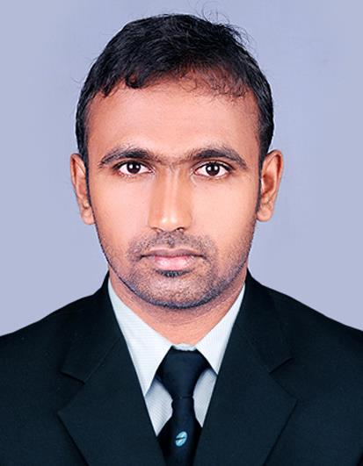
ABDUL
Abdul.381433@2freemail.com
Looking For Civil Autocad Draftsman cum Forman, Autocad Designer, Cad Draftsman , Interior Designer . For Interior Designer ,only looking for The Companies Which Giving Best Training in 3dsmax.
INDIAN Nationality
Looking Job in Middle East UAE, SAUDI, OMAN , BAHRAIN, QATAR, KUWAIT. First Preference is in UAE.
Expert To Handle The Softwares – Autocad , 3ds Max and Basic Office Softwares .
Currently Worked in Sigma Metal Industries in Qatar.
Completed 2 Yearsof excellence From March 07 2015th to June 3th to 2017. [ Experience Certificate Filed ]
Handled Projects Lists
- CONTRACT NO. NPP/0026 CONTAINER TERMINAL INFRASTRUCTURE & UTILITY BUILDINGS [ CLIENT- STATE OF QATAR , PROJECT CLIENT TEAM – NEW PORT PROJECT , PROGRAME MANAGEMENT CONSULTANT – AECOM, ENGINEERING DESIGN CONSULTANT–WORLEY PARSONS ,MAIN CONTRACTOR-CCC ]
- CONSTRUCTION OF BYPASS FROM RAWDAT RASHED VILLAGE TO UMM GARN – PACKAGE – 1 [ PROJECT MANAGEMENT CONSULTANT-PARSONS BRICKERHOFF , DESIGN CONSULTANT-AECOM,MAIN CONTRACTOR-ALCAT ]
- UMM AL SANEEM #1 PREPERATORY BOYS SCHOOL ( PIN#56381986 ) [ CLIENT-ASHGHAL ]
- ROADS AND INFRA STRUCTURE IN BNIHAJER NORTH ( RAWDAT EGDAIM ) PHASES 1 & 2 & PACKAGE 2[CLIENT-ASHGHAL , MANAGEMENT CONSULTANT-PARSONS BRICKERHOFF , MAIN CONTRACTOR –HBK ]
- ROADS AND INFRASTRUCTURE IN NORTH OF MALL OF QATAR AREA & CELEBRATION ROAD , PACKAGE -01[ CLIENT-ASHGHAL , MANAGEMENT CONSULTANT-PARSONS BRICKERHOFF , MAIN CONTRACTOR – HBK ]
- G2-AZIZIYA EAST ROAD IMPROVEMENT TEMPORARY TRAFFIC SIGNS [ CLIENT-ASHGHAL , CONSULTANT-PARSONS , CONTACTOR – HLG ]
- EAST CORRIDOR P011 ( PACKAGE2 ) [ CLIENT-ASHGHAL, CONTRACTOR-CHINA HARBOUR ]
Before that Alsharq Furnitures one year period.
- House Furniture works of Contractors .
- Villas
- Army Camps
Last Salary was 3000QR / Month. Want to Change Job If I get Good Offer . If get Good Opportunity will provide all career skills to the firm with all efforts.
Structural Drafting Experiences From Sigma:-Works Under Signage Drafting Section But Have Experience in Structural Drafting just as a Support Work.
FOLLOWING PROJECTS
- HANDRAIL – NAUFAR [ CLIENT -J&P ]
- HANDRAIL- ENTENSION OF INTERCONTNENTAL HOTEL DOHA, OFFSHORE RESTAURANT , CHALETS AND APARTMENTS [CLIENT-GULF HOTELS COMPANY , OPERATOR - INTERCONTINTAL HOTEL GROUPS , CONSULTANT-DAR AL HANDASAH ]
- PHASE 1B SITE-WIDE- WIRE MESH PARTITION WM-I02-B1-01 [ PROJECT TITLE-MISHEIREB DOWN TOWN DOHA , CLIENT-MISHEIREB PROPERTIES , PROJECT MANAGER-TIME QATAR , EXECUTIVE ARCHITECT-AEB , SUPER VISION CONSULTANT-CEG INTERNATIONAL , MAIN CONTRACTOR-CARILLION ]
Accurate Quantity Surveying and Quantity measuring from Key plan is Other Skill
Experience in India :-Almost 3 years of Experience in the india in small firms firm Lists Follows
- Shan Associates
- My Homes
- Kaff Gallery
- Concept Interiors
Educational Background.:-
Diploma- Diploma in CIVIL CAD And Id Graphics
Degree – B.A
Higher Secondary – Plus Two
S.S.L.C – 10th STD KERALA BOARD
Academical Certificates
- Dip in CIVIL CAD [ CADD CENTRE]
- Dip in Architectural 3d[MIRASH]
- S.S.L.C [Kerala Board of Education]
- Plus Two [Higher Secondary , NIOS[UNIVERSITY]]
- B.A ENGLISH,M.S[UNIVERSITY]
Drafting Courses
- Diploma in ID Graphics[ Syllabus – Drawing Settings, Orthographic Drawings,Isometric Drawings,Perspective Drawings,Editing the Drawings,Annotations and Dimensions,Layer Management,Project Planning and Management. an overview, Selection Methods, Creating and updating repeated elements, Parametric Drawings, Preparing Joinery details/BOM,Presenting the projects, Working with a team, Layout Management,Scale Setting and Plotting,Import and Export]

- Confident and self developing Skill
- High Speed Drafting and Analyzing is positive Skill

- Driving License in G.C.C – Nil ,
- Indian License – Yes
- Marital Status- Married

