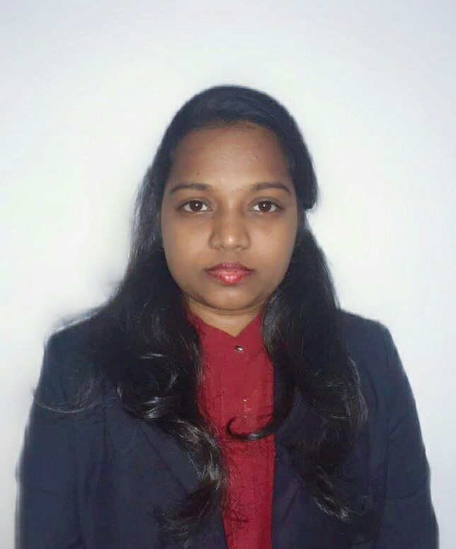
SHERIN
E-Mail: sherin.381448@2freemail.com

Career Objective:
Want to work as an advancing medical coding professional in a challenging and intriguing working atmosphere with the utilization of adept coding expertise and proficiencies.
Professional Summary:

- Certified Medical coder offering a wealth of experience in interacting with office staff, physicians and patients. Hardworking, educated and willing to go the extra mile to complete any task.
- Medical Coder with 3 years’ experience in healthcare software industry.
- Responsible candidate with excellent communication skills.

Key Skills:
- Certified CPC Coder (ICD-10)
- Maintain a good accuracy rate
- Qualified in healthcare billing
- Good knowledge of Human Anatomy and Physiology
- Good knowledge of the Medical Terminologies and procedures
- Promotes positive behavior
- Maintains good rapport with the team members

Work History:

- Medical Coder Feb 2015 -Mar 2018
eClinicalWorks India Private Limited Mumbai, MH

Roles and Responsibilities:
- Receive and review patient charts and documents for accuracy
- Ensure that all codes are current and active
- Report missing or incomplete documentation- Meet daily coding production
- Performs accurate charge entries
- Ensure proper coding on provider documentation
- Serves as resource regarding insurance resolutions and coding questions
- Follows coding guidelines and legal requirements to ensure compliance with federal and state
regulations
- Performs additional duties assigned by Coding Manager as needed

- Registered Staff Nurse Aug 2012 - Aug 2014
Breach Candy Hospital Trust Mumbai, MH

Roles and Responsibilities:
- Partnered with team of registered nurses to achieve overall well-being of all patients.
- Investigated and reported issues relating to patient care or conditions that might hinder
patient well-being.
- Ensured efficacy of treatments through monitoring of treatment regimens.
- Continually improved knowledge, skills and performance based on feedback and self-
identified professional developmental needs.
-Assisted patients with daily functions.
-Developed and implemented nursing care plans.
-Ensured safety and well-being of patients.
-Instructed patients and family members on proper discharge care.
-Provided patient education.

Education:
Exam | University/Institute | Year | Class
SSC | MUMBAI | 2005 | 1st Class
HSC | MUMBAI | 2007 | 1st Class
B.Sc. Nursing | MUMBAI | 2011 | 1st Class

Certifications:
CERTIFIED MEDICAL CODER – CPC

Hobbies & Other Achievements:

- Passionate about music
- Stage Performer since school days
- State Level Winner in Light music at mahar4ashtra university of health sciences
- Served as Gen. Secretary in a spiritual youth forum (Malankara Catholic Youth Movement)
- Fond of pets
- Love to travel different places
- Keen interest in reading Spiritual Books

