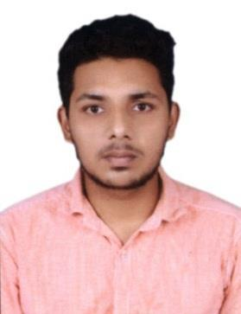
IGNETIOUS
Email Id Ignetious.381462@2freemail.com

OBJECTIVE

To seek a challenging position in engineering industry that needs innovation, creativity, dedication and enable me to continue to work in our company. With my current knowledge and fostering creativity with many learning opportunities.

QUALIFICATION

Bachelor of Engineering in MECHANICAL ENGINEERING at RVS Padhmavathy College of Engineering and Technology with 76.5% (Affiliated to ANNA University)

HIGHLIGHTS

- An enthusiastic person with highly motivated and leadership skills having bachelors of engineering degree in Mechanical Engineering.

- Ability to Multi-task and organize functions within any environment and given deadline.

❖ Good knowledge of designing.  Disciplined and loyal.
❖ Eager to learn new technologies and  Good numeric ability.
methodologies.

EXPERIENCE

Company: TVS SFL under Contract of BETS ENGINEERING (NOV 2016 to NOV 2017)

Acting role: Quality Engineer.

Responsibilities:

- To meet customer quality needs according to applications like mechanical properties.

- Check the mechanical properties of the given job as per standards and customer needs.

- Checking Sequence of operation in Heat treatment processes of Furnace

- Communicating to Works Manager regarding commitment problem, process delays and update status.

- Effective utilization of resources like man, machine & material.

PROFESSIONAL SUMMARY

- Have 1 years of competitive experience in engineering industry.

- Experience in Maintenance and Quality of Industry.

- Able to handle Heat treatment process for materials

- Able to manage system of process.

AREA OF INTEREST

- Production and Manufacturing

- Quality

- Maintenance

- Designing

SOFTWARES KNOWN

- AUTOCAD 2D&3D.

- REVIT MEP.

- MS OFFICE with specialization in EXCEL, WORD and PPT.

CERTIFICATIONS

- AUTOCAD Certificate from Trinity ( Id :TST180206 )

- REVIT MEP Certificate from Trinity ( Id :TST180207 )

PERSONAL DETAILS

Date of Birth : 31st July, 1995

Nationality : Indian

Sex : Male

Languages Known : Tamil, English, Malayalam, Hindi.

Visa Status : Visit Visa

DECLARATION

I hereby declare that all the above information given is correct to the best of my knowledge. I would be glad to provide any other information required by you.

