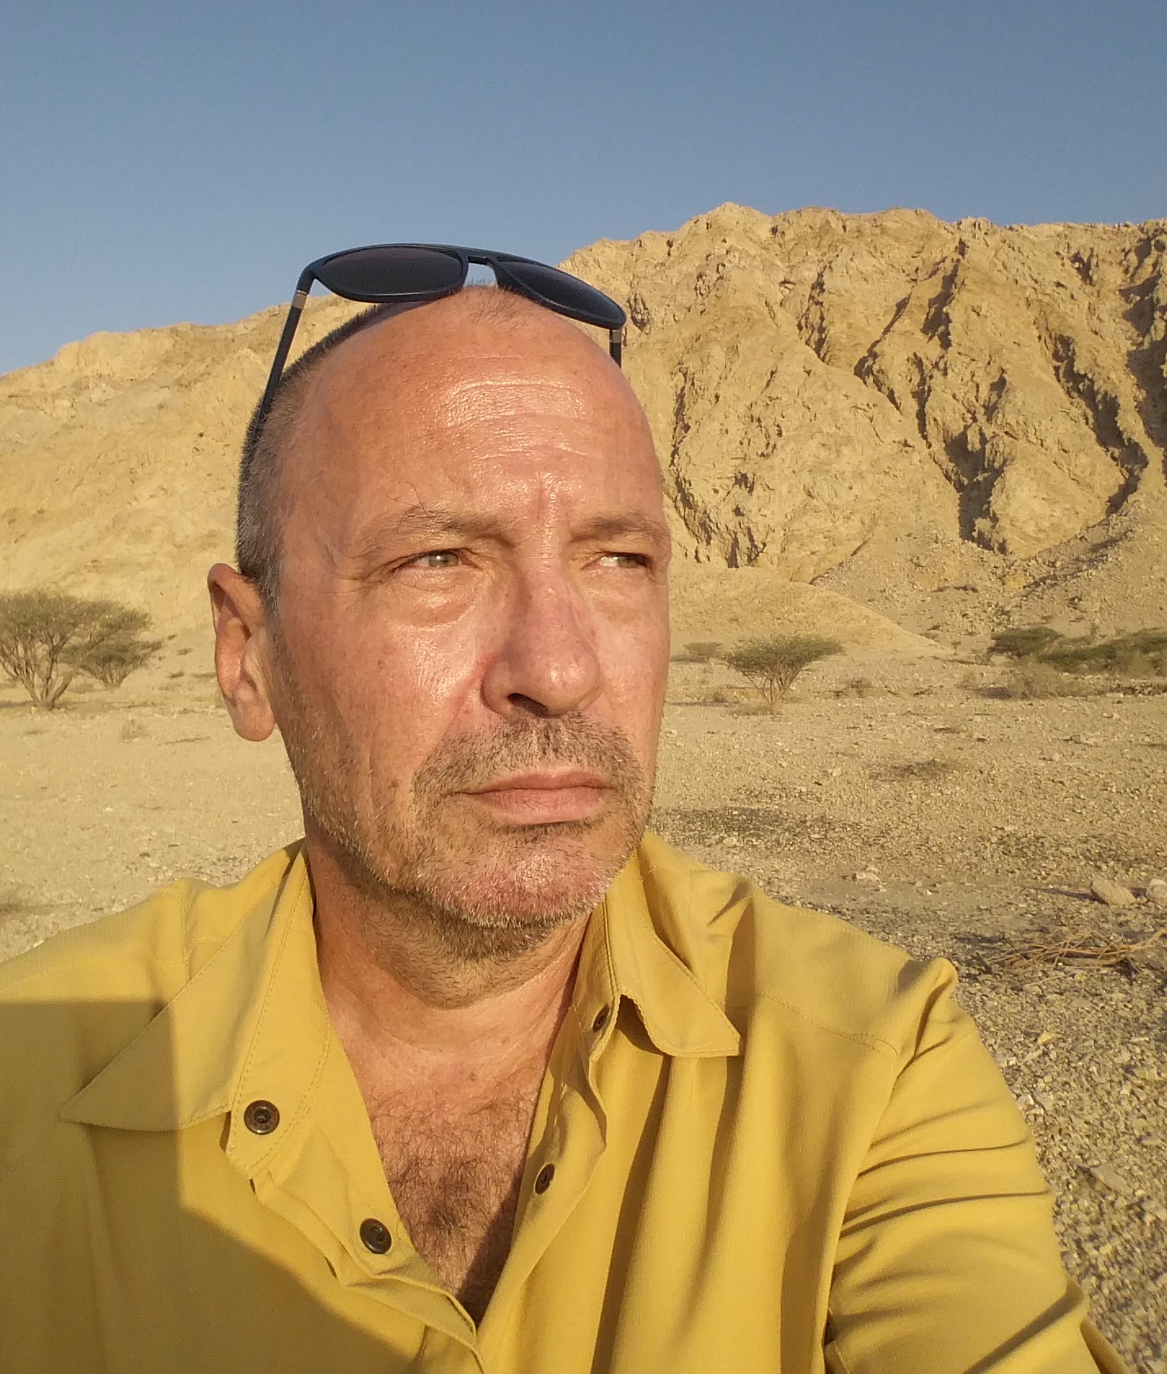 | Vladimir  Journalist, Team Manager  French National  UAE Resident  NMC Press Card holder  Contact :  Vladimir.381489@2freemail.com

PROFESSIONAL EXPERIENCE

Journalist, Communication Advisor, Analyst, 2015-present
United Arab Emirates

Strategic Media Consultant / Journalist 2009 – present
Several, France & Switzerland
- political and business country analysis for foreign investors

News Editor – European Broadcasting Union Geneva 2000 - 2009
European Broadcasting Union (EBU), Switzerland (300+ staff)
- daily management of several News crews in-house and abroad (73 TV members accross 56 countries);
- choice of News, Live feeds, interface and assignements with and for all European TV teams and News agencies ; APTN, Reuters, AFP

Head of Bureau – European Broadcasting Union Moscow 2000 - 2002
European Broadcasting Union (EBU), Russia,
- responsible towards Russian authorities for the Bureau
- special news operations, news feeds, 20 staff and budget manager (USD 3M+)
- first crew to enter Afghanistan via tha Notrth (Tajikistan) with two tons of broadcasting equipment within 48 hours while all other major News outlets stuck on the Pakistani border
- CFO for Russia and CIS budget (approx. USD 10 million)

Deputy Editor-in-Chief - Euronews France 1997 - 2000
- Head of News (200+ staff), editorial, news & Lives output daily management of daily 7 multilinguistic teams ( English, French, German, Italian, Russian Spanish and Portuguese) multi-language News team up to 40 at a time
- all platforms,programme launcher (« Flashback », « No Comment Live ») ;

Duty Editor - Euronews France 1995 - 1997
- News output, Live transmissions, recruitment,

Senior Correspondent - Radio France, Le Figaro 1990 - 1995
- war zones covers ex-Yugoslavia and ex-USSR, Caucasus and Central Asia

Senior Producer, Reporter, News Presenter - BBC World Service 1986 - 1990
- Europe and Africa News & Special Reports
- several quotes for excellence in BBC monthly review

Press photographer - Imapress, Paris 1984-1986

SKILLS

Video shooting and editing
Broad view and creativity
Communications and Crisis Management
Professional and Cultural Adaptability & Flexibility
« Calm in the Storm » - team confidence builder

PERSONNAL EXPERIENCE

President of the Euronews Journalist Society 1997-2000
Member of the Board of the French-Romanian Medical Relief Association since 1989
Member of the Board of the French-Moldovan Medical Supplies Association since 1991

LANGUAGES

French, English, Italian, Russian, Romanian, Spanish
Arabic underway

STUDIES

Political Science - Paris
Business Law – Paris

