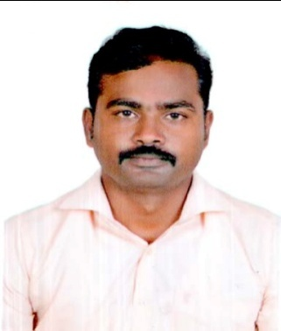
Curriculum Vitae

chithu

chithu.381513@2freemail.com

OBJECTIVE:

To make a positive impact in my field of activity leading to Organization growth by creative application of my value based convictions and professional divinity by putting my all efforts in the work assigned to me in an organization where I can grow along with the organization.

PROFESSIONAL QUALIFICATION:

- MBA from Muthayammal Engineering College, Rasipuram, Anna university-Coimbatore.

- Year of passing-2009.
- Percentage-74%.
- Specialization- Finance & Marketing.

ACADEMIC QUALIFICATION:

- B.com from Periyar E V R College Trichy, Bharathidasan University-Trichy.

- Year of passing-2007.
- Percentage-62%.
- Specialization-Commerce.

- Higher secondary from St.Antony hr. Sec.school, Chinna Salem, State Board.

- Year of passing-2004.
- Percentage-77%.
- Specialization-Commerce.

- 10th from Govt High School, Thagam Theer Tha Puram,State Board.

- Year of passing-2002
- Percentage-68%

PROFEESTIONAL AND WORKING EXPERINCES:
- Two Years Experience to Head Checker in Mansour Al Mosaid co.,Ltd.Jeddah Islamic Sea Port Project (Multipurpose)- Saudi Arabia.

Unloading and Loading (Import and Export) of cargoes on ships here are various other dockside responsibilities and duties involved under this occupation.
Our Company Port Project–Cargoes, Containers, Bulk, RoRo.
Job Description:
- Agent Request unloading and Loading of cargoes.
- Coordination to Capitan or Chief Officers and Agent.
- Preparation billing to unloading and loading all cargoes.

- Two Years Experience to Accounts Manager in Hero Motocorp LTD on Show Room in Chinnasalem-Tamil Nadu.
Job Description:
- Fund & Cash Flow Management.
- Tally Software and Stock and Bank balance Maintained.
- Sales & Income tax filing.
- Purchase and sales Invoice entry.

- Five Months Experience to Site Manpower coordinator in United Precast concrete Dubai L.L.C
Job Description:
- Employee time sheet entry, Site Job allocates.
- Employee salary making, Reporting to project engineer.

- Eight Months Experience to Junior Assistance in Manapuram General Finance and leasing limited in Tamil nadu.
Job Description:
- Jewell appraisal.
- Jewell Loan approve.
- Manager coordination.
- Cashier.

PROJECT UNDERTAKEN:

- A study on customer satisfaction towards the men beauty Parlours.
- A study on customer perception towards Aviva life insurance .

IT SKILLS:

- MS – Office
- Tally 7.2
- SAP

LANGUAGE SKILL:

- Writing –English, Tamil.
- Speaking- English, Tamil, Telugu, Hindi, Arabic.

PERSONAL PROFILE:

- Date of birth : 25-07-1987
- Nationality : Indian
- Gender : Male
- Marital Status : Married

CERTIFICATION:

I the undersigned, certify that the above statements are true to the best of my knowledge and belief.

