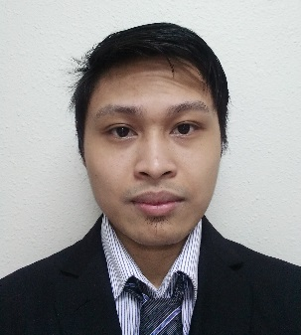
Valeriano
Mechanical Design Engineer

Dubai, United Arab Emirates
Valeriano.381517@2freemail.com

Professional Summary | - Detail-oriented Mechanical Engineer with 4+ years’ combined experience as Static Equipment Design Engineer and Mechanical Design Engineer. Can perform strength calculation for Pressure Vessel, Heat exchanger, and Column. Can perform load calculation for HVAC system, Plumbing, and Fire Fighting System.
Software | AutoCAD  Autodesk Inventor  COMPRESS  PV Elite  Navisworks  SmartPlant Review  MicroStation  Hourly Analysis Program  Elite CHVAC  Elite Fire
Experience | ENSIAB ENGINEERING  CONSULTING – Jubail, KSA Oct. 2017 –June 2018  Mechanical Design Engineer  - Plan and design of HVAC System, Plumbing, and Fire Fighting System  - Develop Mechanical layouts for HVAC, Water Supply, Sanitary, and Fire Fighting  - Familiar with International codes and standards like ASHRAE, NFPA, and IPC  - Develop man-hour/cost estimate and schedule to carry out engineering/design  - Perform calculation of HVAC System, Plumbing, and Fire Fighting System  - Incorporate all review comments and issue final detailed engineering/design packages  - Coordinate with various engineering disciplines  DASH ENGINEERING  PHILIPPINES INC. – Mandaue, Philippines Nov. 2013 – Feb. 2017  (A Subsidiary of Mitsui Engineering & Shipbuilding Co., Ltd.)  Static Equipment Design Engineer  - Design of Pressure Vessel, Heat Exchanger (shell and tube), and Column  - Develop Mechanical data sheet, Loading data, Technical Bid Evaluation, and other project related documents  - Develop General Arrangement drawings and detailed fabrication drawings using AutoCAD and Autodesk Inventor  - Perform calculation and analysis of Pressure Vessel, Heat Exchanger (shell and tube), and Column both manually and by COMPRESS software  - Familiar with International codes and standards like ASME Sec. VIII Division 1 and Division 2, TEMA, & API  - Review vendor’s drawing/documents and preparing technical queries  - Review 3D model for interference check using Navisworks and SmartPlant Review  - Coordinate with Process, Piping, Civil, Electrical, Instrument, and Project group on finalizing
Projects | VISITOR AND ID OFFICE AT UNITED SABIC (Jubail, KSA)  MAKANA STEEL FABRICATION SHOP (Ras Al-Khair, KSA)  SINGAPORE BUTYL AND aDHESION (Jurong, Singapore)  PO & POLYOLS PROJECT (Rayong, Thailand)  FPSO LIBRA PILOT, FPSO SEPIA(Offshore, Brazil)
Education | University of cebu-main campus  Bachelor of Science in Mechanical Engineering  Graduate with Academic Excellence with second Honors  GPA: 1.47
License | registered mechanical engineer

