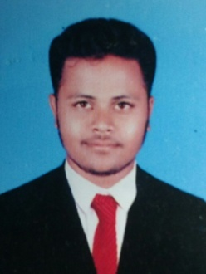
CURRICULUM VITAE

ADIL
Email: adil.381519@2freemail.com

Career Objective:
Dynamic Civil Engineering Professional gained 3 years & result driven versatile experience aspiring a career growth in the field of construction industry to utilize acquired skills and knowledge in achieving organizational goals, while attaining personal and professional growth. Seeking a challenging assignment as a Civil site Engineer

Professional Experience:
Worked as “Site Engineer” for Prestige Group of Construction, Since July 2015 to April. 2018.
Role &Responsibilities:
1. Project: ‘The Clover Leaf’ , Hyderabad.
2. Project: Maple, Hyderabad.
- Preparing abstracts for site utilities.
- Planning weekly programs and tracking the work.
- Preparing bill of quantities.
- Generation of daily weekly and monthly reports.
- Preparing payment bills for the contractor.
- Good knowledge of execution of structure and block work as well.
- Maintaining the quality of work.
- Setting out Project works in accordance with Drawings & Specification.
- Maintenance of daily record.
Technical &Software Skills:
- Auto CAD
- Microsoft Office (Project, Excel, Word, Power point).

Educational Project& Seminar:

- A project on “Preliminary survey of Minor irrigation storage tank".
- A seminar on “Precast & Pre-stressed hollow core concrete slab".

Educational Qualification:

Examination | Discipline /  Specialization | School/  College | Year of passing | Result
B.E | CIVIL | HIMES Institute Of Management & Engineering Studies, Hyderabad. | 2015 | 67.65%

Personal Profile:
Date of Birth : 21thSEP 1993.
Nationality : Indian.
Languages Known : English, Urdu, Hindi and Telugu.
Marital Status : Single.

I declare that all the information given above is true to the best of my knowledge.

