CURRICULUM VITAE
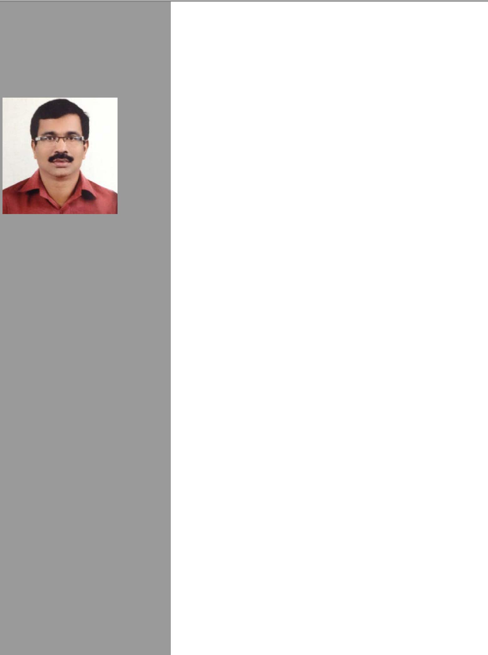

RAJESH

Email: rajesh.381509@2freemail.com

Objectives:

To be successful team player with hard work, dedication & integrity and to gain as much practical knowledge as possible by working in an established company, so as to enhance my skills and add value to the organization.

Professional Experience:

13 Years of experience in Drafting Career Summary:

- Company : COMBINED GROUP CONTRACTING EST.

Period : Since January 2016 to 2017 October

Designation: Architectural Draughtsman

PERSONAL DETAILS:

Date of Birth : 23th April 1973
Sex : Male
Nationality : Indian
Marital Status : Married Languages Known:
English, Hindi, Malayalam.

VISA STATUS:-

Employment Visa
(Readily available to join on your query)

- Company : CHINA STATE CONSTRUCTION

ENGINEERING CORPORATION MIDDLE EAST DUBAI - U.A.E.
Period : Since January 2015 to 2016

Designation: Architectural Draughtsman

➢ Company : Dubai Civil Engineering co, DUBAI - U.A.E.

Period : Since June 2006 to January 2015

Designation: Architectural Draughtsman

Responsibilities:

- Preparing Architectural General Arrangement drawings.
- Co-ordinate with engineers for modification and revisions.
- Preparing “Fit Out for construction” drawing.
Projects executed:

- Commercial Complexes
- Residential Buildings
- Villas
- Ware house

Projects undertaken/ongoing

- Construction, completion and maintenance of Sheikh Zayed Housing Programme Residential Compound- Umm Al Quwain
(232) Houses
Consultant: Al SUWEIDI ENGR. CON.

- 3B+G+ 34 Residences. Bldg named as TIME PLACE TOWER in Dubai
Consultant : M/s. National Engineering Bureau

- 3B+G+M+35 (4 Towers) Residence & villa. Bldg named as PARK ISLAND in Dubai
Consultant – M/s. Noor.

- 4B+G+M+49 (3 Towers) Residence. & Hotel Bldg named as BAY CENTRAL in Dubai
Consultant – M/s. National Engineering Bureau

- 4B+3P+G+16 Commercial Bldg. named as EMPIRE HEIGHTS at Residence Business Bay, Dubai Consultant – M/s. Mazaya Engineering

- 3B+2P+G+20 Hotel Apartment Bldg named as AL BARREQ TOWER in Dubai

Consultant – M/s. National Engineering Bureau

- 3B+3P+G+16 Commercial/Hotel/Furnished Apartment Bldg. named as SYMPHONY TOWER in Dubai

Consultant – M/s. Arif & Bintok
g ) B+G+13+Roof /Arenco Hotel Resort Project palm
Jumeirah

- Company: Century Contracting Company

Sultanate Of Oman

Worked as a Civil Draughtsman for 2 years

Project carried out

QSSR Al Alam Muscat Palace in Muscat

Projects executed:

- Different type’s projects (Villas, Commercial Complex & Hospitals & Public Buildings) at different Places in Kerala (state) In India.

Educational Qualifications:

- DIPLOMA IN CIVIL ENGINEERING

STATE BOARD OF TECHNICAL EDUCATION &
TRAINING, KERALA

- DIPLOMA IN AutoCAD

- CADD CENTER, BANGALORE, INDIA

DRAUGHTSMAN COURSE NATIONAL TRADE CERTIFICATE

- Pre Degree

- S.S.L.C Computer Skills:

Operating system Professional : Windows 98, 2000, XP

Drawing packages : AutoCAD 2D (AutoCAD 2000 to 2015)

General package : MS Word, and MS Excel.

Competencies:

Fast learner, adapt well to changes and pressures in work place ,

Work effectively with diverse groups of people, friendly with an upbeat attitude, ambitious, hardworking and committed to excellence, deadlines and schedules.

