Andrew , phrn, haad-rn, cpc-a | 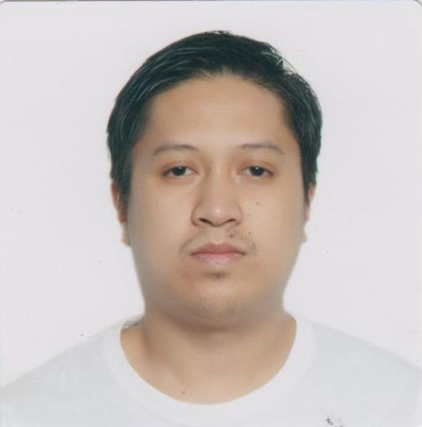
[Type your address]
Email: andrew.381570@2freemail.com

JOB DESCRIPTION

Medical Coder

JOB OBJECTIVE

- Seeking a position where I can utilize my coding skills, experience with patient records, and background in medical terminology to accurately abstract and validate ICD-10-CM and CPT codes, maintain patient records, and assist a facility overall in their documentation and reimbursement process.

- To work on a setting using my skills as a medical coder will be enhanced as well as my interpersonal relationship among other professionals.

PERSONAL INFORMATION

Name: Andrew
Gender: Male
Civil Status: Married
Citizenship: Filipino
Birthday: November 13, 1986
Height: 167 cm
Weight: 72 kilos
Religion: Roman Catholic
Language: Proficient in English, Filipino, Basic Arabic (Speaking)
Personal Qualities: Hardworking, diligent and willing to learn
Health: Excellent
Visa Status: Wife (Residence) Visa

QUALIFICATIONS

- Certified Professional Coder (CPC-A) as of June 9, 2018
- Bachelor of Science in Nursing Graduate
- Nursing Licensure Examination (NLE) Passer (December 2007)
- Saudi Commission for Health Specialties Passer (July 2010)
- Health Authority – Abu Dhabi (HAAD) Licensure Examination Passer (September 2015)
- Trained in Advanced Cardiovascular Life Support
- Trained in Basic Life Support

PROFESSIONAL LICENSE

- Certified Professional Coder (CPC) : June 9, 2018
AAPC

- Licensing Body : Professional Regulation Commission (PRC)
Professional Status : Registered Nurse
License/Registration Number : 0469323
Registration Date : April 4, 2008
Validity Date : November 13, 2019

- Licensing Body : Health Authority – Abu Dhabi (HAAD)
Professional Status : Registered Nurse
License/Registration Number : GN27663
Registration Date : January 17, 2016
Validity Date : January 17, 2018

- Licensing Body : Saudi Commission for Health Specialties (SCFHS)
Professional Status : Registered Nurse
License/Registration Number : 10-J-N-0328978
Registration Date : July 2010
Validity Date : July 2016

EDUCATIONAL BACKGROUND

College 2003 – 2007 Pines City Colleges
Magsaysay Avenue, Baguio City
Bachelor of Science in Nursing

Secondary 1999 – 2003 Baguio City National High School
Governor Pack Road, Baguio City

Elementary 1993 – 1999 Magsaysay Elementary School
Lucban Street, Baguio City

AFFILIATIONS

- American Academy of Professional Coders
Current member March 2018 up to present
Membership ID: 01601880

WORKING EXPERIENCE

April 2014 – April 2017 : Medical-Surgical Ward Staff Nurse
Region 1 Medical Center
Dagupan City, Pangasinan

March 2010 – March 2014 : Emergency Room Staff Nurse
Al – Hayat Hospital
Jeddah, Kingdom of Saudi Arabia
January 2009 to July 2009 : Staff Nurse
Benguet General Hospital
La Trinidad, Benguet

March 2008 to December 2008 : Volunteer Nurse
E.D. Lim Maternity and General Hospital
Apalit, Pampanga

SKILLS AND TRAITS

- ICD-10, CPT, HCPCS
- Anatomy, Physiology, Pharmacology
- Knowledge of HIPAA and Patient Confidentiality
- Proficient in Microsoft Office
- Excellent in English Verbal / Written Communication
- Basic Arabic (Speaking)
- Knowledge of Medical Terminology
- Reliable, trustworthy, hardworking, job committed and willing to be trained.

TRAININGS ATTENDED

- 80 Hours CPC Medical Coding Training (ICD-10, CPT, HCPCS)
Time Training Center
Electra Street, Abu Dhabi
March 2018
- Advanced Cardiovascular Life Support (ACLS)
American Heart Association (AHA)
FDM Training Center for Allied Health Prof. (Philippines)
August 9, 2017
- Basic Life Support (BLS)
American Heart Association (AHA)
FDM Training Center for Allied Health Prof. (Philippines)
August 8, 2017
- ECG and Pharmacology
American Heart Association (AHA)
FDM Training Center for Allied Health Prof. (Philippines)
August 7, 2017

SEMINARS ATTENDED

- Diabetes Management
November 16, 2017
Nightingale Training Center (Abu Dhabi)
- Basic Infection Control for Healthcare Providers
November 9, 2017
Nightingale Training Center (Abu Dhabi)
- Pain Management
September 7, 2017
Nightingale Training Center (Abu Dhabi)

I hereby certify that the above-mentioned facts are true to the best of my knowledge and ability.

ANDREW
Applicant

