NIDHIN

Email:
Nidhin.381582@2freemail.com

Current Address: Dubai, UAE

Other Qualifications:

- Inventory Management

- MS Office

- Kuehne Nagel software (CIEL)

.

Driving Licence :

India Driving License(Kerala) M/CYCL.WG, LMV

Languages Known:

English, Hindi,Tamil, Malayalam

RESUME
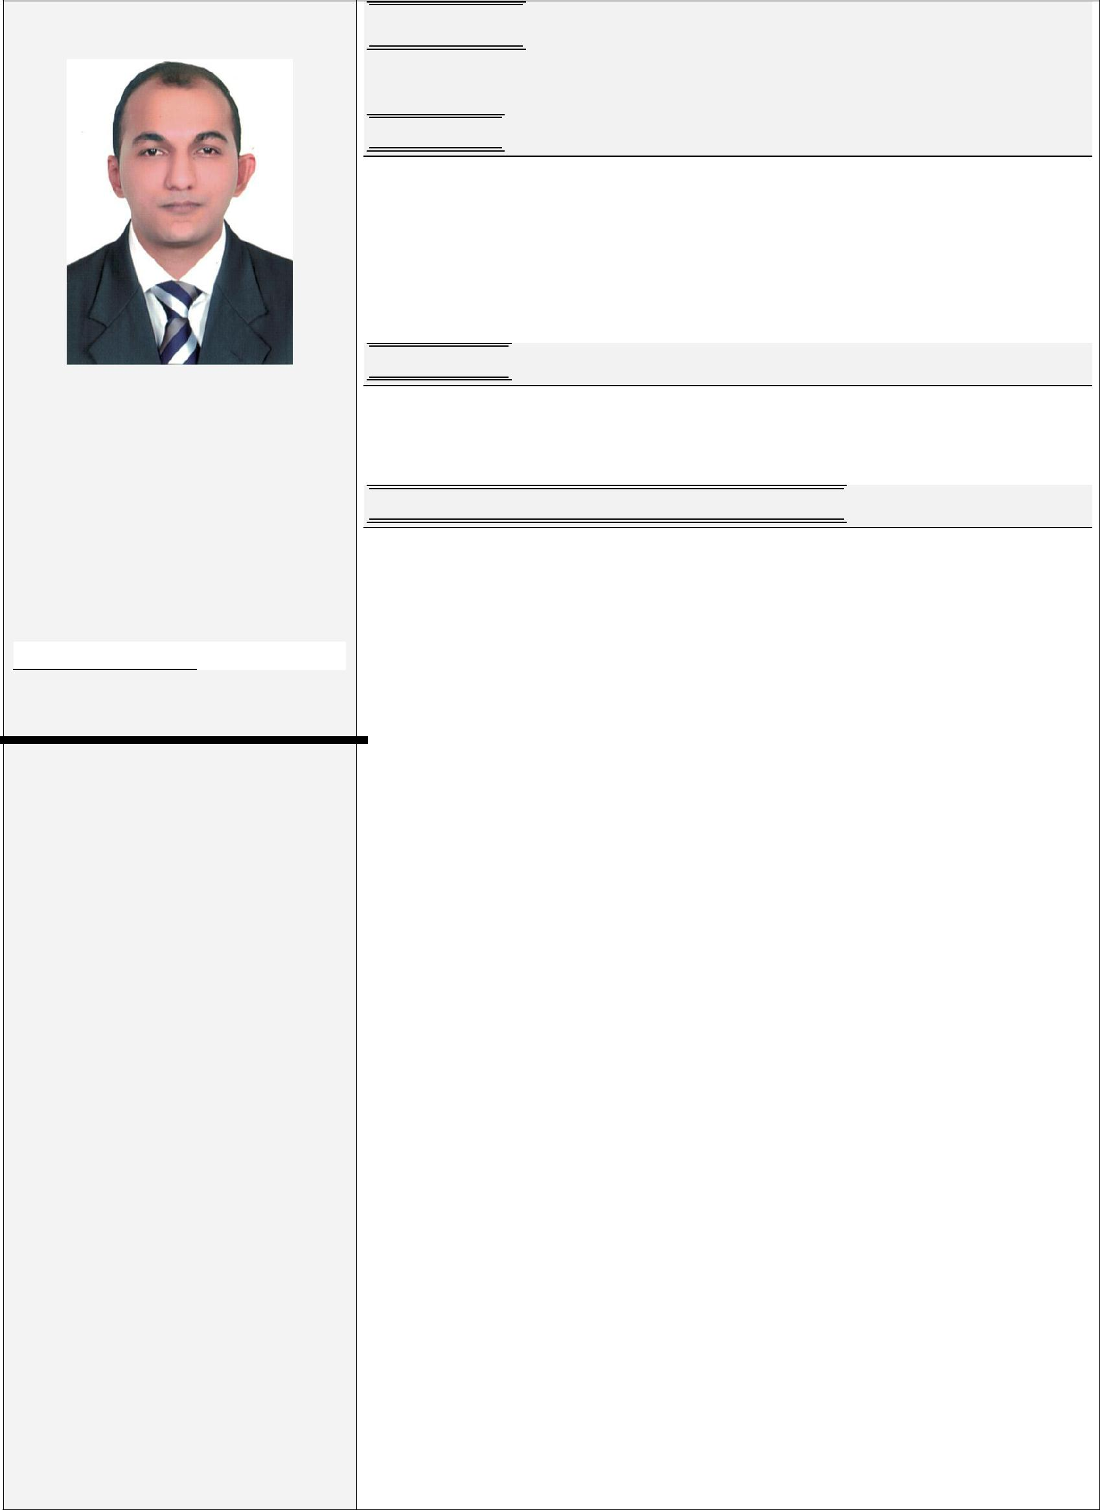

Objectives :

To be associated with an Organization that gives me scope to update my knowledge and skills in accordance with the latest trends and be part of a team that dynamically works towards growth of organization and gains satisfaction thereof.

Experience :

Possess 2 Years Experience as Admin assistant and Team leader. Possess 1 Years Experience in Customer Service

Employment / Working Experience History

KUEHNE + NAGEL PVT LTD, KERALA
Designation : Admin Assistant, Team Leader

Duration : From January 2014 to January 2016.

From January 2014 I was working with Kuehne + Nagel Pvt Ltd Kalamassery as Admin Assistant and Team Leader till January 2016 taking care of stock system details of Toshiba under payroll of Aarkay’s Consultants.

- Entrusted to manage office in the supervisor’s absence. Provided timely, courteous and knowledgeable response to information requests; and prepared official correspondence.

- Controls inventory levels by conducting physical counts; reconciling with data storage system.

- Maintains warehouse staff by recruiting, selecting, orienting, and training employees.

- Achieves financial objectives by preparing an annual budget; scheduling expenditures; analyzing variances; initiating correctiv actions.

- Complies with federal, state, and local warehousing, material handling, and shipping requirements by studying existing and ne legislation; enforcing adherence to requirements; advising management on needed actions.

- Communicated effectively with multiple departments to plan dail scheduled activities of the warehouse

- Established strong relationships to gain support and effectively achieve results.

Personal Data :

Date of Birth : 29-03-1993

Nationality | : India
Marital Status : Unmarried
Visa Status | : Tourist
.

Computer Age Management Services

Designation : Customer service executive

Duration : From February 2016 to January 2017.

From February 2016 I was working with CAMS insurance call center Chennai as customer service executive till January 2017.

- Manage large amounts of inbound and outbound calls in a timely manner

- Follow communication “scripts” when handling different topics

- Identify customers’ needs, clarify information, research every issue and provide solutions and/or alternatives

- Seize opportunities to up sell products when they arise
- Build sustainable relationships and engage customers by taking the extra mile

- Keep records of all conversations in our call center database in a comprehensible way

- Frequently attend educational seminars to improve knowledge and performance level

- Meet personal/team qualitative and quantitative targets

Professional Educational Qualification :

Qualification : ITI ELECTRONICS

(2013) with 65.0% Aggregate.
Institution : Don Bosco Tech Vaduthala
University : National Council for Vocational Training.

Qualification: HSCC (12th)-(COMMERCE)(2010)
Institution : Sree Gujarathi Vidyalaya Higher Secondary School
University : Government of Kerala

Qualification: SSLC (10th-2008).
Institution : Lorreto Anglo Indian High School, Kochi,.
University : Government of Kerala.

Strengths :

- Committed, hard working, Time Consciousness, Result Orientation.

- Commitment of Quality, Team Work, Planning & Organizing.

- Problem Solving, Decision Making, Customer Focus.
- Ability to deliver in challenging environments.

Declaration :

I hereby declare that all the details provided above are true to my knowledge and if I am placed in your concern I promise you that I will bring in the best of myself for the prosperity of the organization and to the entire satisfaction of my superiors.

