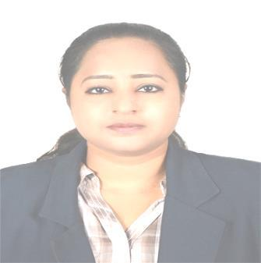
Tabassum

Email Address: tabassum.381586@2freemail.com

Dubai – U.A.E

Career Objective

To seek a responsible position, in a growth-oriented company, where my experience, accomplishments, and proficiency will allow me the opportunity for personal and professional growth.

Strengths and Professional Summary

- Good analytical and Interpersonal Skills.
- Good telephone manner.

- Hardworking and capable of working well under pressure.
- Strong passion for customer service – always ready to go the “extra mile”.

- Excellent team player and easily adapt to changing work environment.

Work Experience

Magna Info Tech (from: Jan2013 - June2014)
Admin Assistant/ Document Controller
Responsibilities

- Receives and register client provided document for detail

- Maintains specifically assigned documents

- Ensures proper document classification, sorting and filing

- Review completeness of documents and prepare document transmittals

- Performs document quality check in accordance to company

- The documents will keep in the filing room safely with specific subject

- Ensure invoices have gone through detailed verification.

- Prepare Payment to suppliers.

- Recording all payment and receipts
Alirits- Spectrum IT (From: July 2014To May2017)

Admin Assistant cum Recruiter
Responsibilities

- Write and distribute emails, correspondence memos, letters, faxes and forms.

- Maintain accommodation and transportation for company's staff.

- Making LPO's (local purchase order) and receiving the invoices for payment.

- Responsible of all staff's transportation on different locations.

- Coordinate with HR(Human Resources )schedule appointments.

- Assist in the preparation of regularly scheduled reports.

- Develop and maintain a filing system.

- Update and maintain office policies and procedures.

- Maintain contact lists.
- Provide general support to visitors

Medze Healthcare LLC( from July 2017 - Janurary 2017)
Reception cum Junior Accountant

Responsibilities:

- Write and distribute emails, correspondence memos, letters, faxes and forms.
- Maintaining petty cash transactions
- Recording all bank receipts and payments
- Welcoming guest
- Organize and schedule appointments.

- Assist in the preparation of regularly scheduled reports.
- Develop and maintain a filing system.
- Maintain contact lists.
- Provide general support to visitors.

- Making LPO's (local purchase order) and receiving the invoices for payment.

Mars Era Contracting LLC (from March 2018-Current date)

Accounts assistant, Admin assistant, Receptionist, Documentation controller

Responsibilities:

- Write and distribute emails, correspondence memos, letters, faxes and forms.
- Welcoming guest
- Answering the calls.

- Organize and schedule appointments.
- Assist in the preparation of regularly scheduled reports.
- Develop and maintain a filing system.
- Maintain contact lists.
- Provide general support to visitors.
- Making vouchers according to the transactions.

- Updating the vouchers in M.S Excel sheets as per required.

- Order office stationary .
- Research new deals and suppliers.
- Taking quotations from the suppliers.

- Making LPO's (local purchase order) and receiving the invoices for payment.
- Applying bills on online i.e in Zoho books accounts for VAT.

Educational Qualifications

Bachelor of commerce from St. George Degree College in 2008

Computer Skills

- Microsoft Office

- DBMS

- Tally

Personal Information

Civil Status | : | Single
Gender | : | Female
Nationality | : | Indian
Visa status | : | visit Visa

