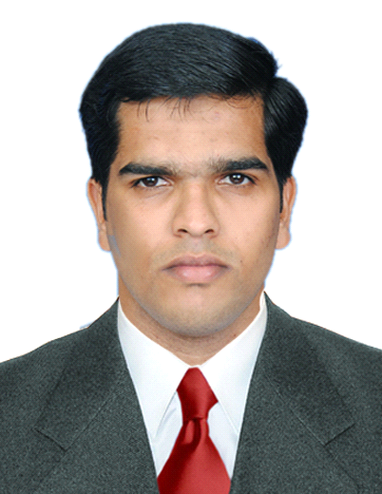
safnas

E-mail: safnas.381592@2freemail.com

Career Objective

Obtain a position as a team-player in a people-oriented organization where I can maximize my customer-service experience in a challenging environment to achieve the corporate goals.

Work Experience

- Worked as a Business Developement Officer in BAPUJI SURGICALS (August 2017 to june )
- Worked as Sales Executive in KGT COMMUNICATIONS DUBAI (December 2016 to May 2017)

- Worked as Sales Manager in Reliance Life Insurance Co Ltd.
Calicut, Kerala. (Jun 2013 – Aug 2014)

- Agent Management – Identifying, Recruiting and managing them.
- Ensure and maintain productivity levels of Advisors.
- Hire agents to achieve maximum business.
- Monitor and Review agents Performance.
- Training them with the help of training team.
- Meeting customers on regular basis.

- Worked as a Re-Finance Marketing Officer in IndusInd Bank.
(Personal product division) Calicut, Kerala. (May 2010 to Nov 2012)

- Recruitment process
- Co ordinate whole functions of concerned branch
- Motivate employees and doing sales promotional activities
- Check and verified whole documents
- Giving approvals for loan
- Marketing officer for re-Finance.

Academic Profile

- B. Com - Co-operation (2008 - Calicut university)
- Plus Two – Co-operation (2005 - Board of Higher Secondary Education, Kerala State)
- SSLC (2003 - Board of Public Examinations, Kerala State).

Personal Summery

Age & Date of Birth : 29, 05/02/1988
Sex : Male
Marital Status : married
Religion & Caste : Islam, Mapila
Nationality : Indian
Mother Tongue : Malayalam
Linguistic Proficency : English, Hindi & Malayalam.

