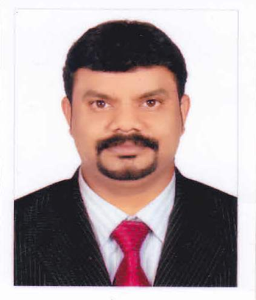
Sreekumar

Email Id: sreekumar.381595@2freemail.com

CAREER OBJECTIVE:

Seeking a position utilizes my skills and abilities and to make the optimum utilization of potential that offers professional growth while being resourceful, innovative and flexible.
WORK EXPERIENCE:

- SEAPEARL hotel, KERALA, INDIA (2013- Till Date) as STOREKEEPING SUPERVISOR
- SADACA Cleaning Project, Saudi Arabia(2007-2012) as STOREKEEPER, TRANSPORTATION SUPERVISOR ,CLEANING SUPERVISOR

- Assigns workers their duties and inspects work for conformance to prescribed standards of cleanliness.
- Investigates complaints regarding housekeeping service and equipment, and takes corrective action.
- Obtains list of rooms to be cleaned immediately and list of prospective check-outs or discharges to prepare work assignments.
- Coordinates work activities among departments.
- Makes recommendations to improve service and ensure more efficient operation.
- Attends staff meetings to discuss company policies and patrons' complaints.
- Issues supplies and equipment to workers.

- AL-BHARI Fencing Factory Dubai,UAE(2012-2013)

- Company Profile : Fencing & Trading Company.
- Job Profile :SALE MANAGER,STORE INCHARGE
( Works related to sales , Purchasing,storeincharge,etc )

- Reliance Web World Express Kerala,India(2003to 2007)
Company Profile : Leading Telecom company in India.
Job Profile : STOREKEEPER & SALES INCHARGE Works related to Marketing, STOCK UPDATES
SKILLS:

- Self starter, motivated, with sound track record of finance industry and leadership qualities.
- Strong conceptual, analytical and problem solving skills.
- Work confidently under pressure.
- Responsibility and commitment towards assignments
- Positive mental attitude and passionate towards work.
EDUCATIONAL QUALIFICATION:

- Diploma In Electrical
COMPUTER SKILLS:

- MS Office
PERSONAL DETAILS:

Date of Birth : 30.05.1980
Marital Status : Married
Nationality : Indian
Languages Known : English, Hindi, Malayalam, Arabic, Tamil, Telugu
and Kannada.
Extra Curricular Activities : Internet Surfing, Reading and
Listening to Music

