CURRICULUM VITAE
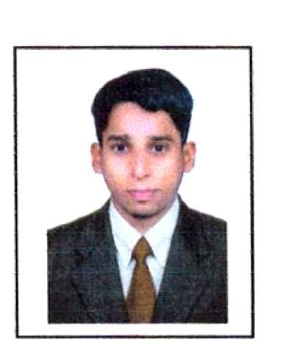

Name E-mail

AWAYZ

Awayz.381613@2freemail.com

OBJECTIVE:

A proactive, customer-focused Sales Assistant with successful sales experience and a positive, confident approach. Well-developed skills in forming trusting relationships with customers as well as quickly reacting to their needs and presenting the most apt products and services. Able to work well both in teams and on own initiative, with a proven record of contributing to process improvements. Resilient and confident, and works well under pressure. Seeking a role within a health and beauty company in which to use acquired skills and interests

PROFESSIONAL WORK IN INDIA:

Duration | : | AUG 2017 to 01-04 2018
Position | : | Sales cum Accountant
Product | : | ELECTRONICS & HOME APPLIANCES
Organization | : | ENVIROFIT PVT LTD CO. Bangalore

DUTIES AND RESPONSIBILITIES:

- Review all invoices for appropriate documentation and approval prior to payment
- Sort and distribute incoming mail

- Process 3 way P.O. matching invoices, up to 100 plus line items
- Prioritize invoices according to cash discount potential and payment terms
- Process check requests
- Match invoices to checks, obtain all signatures for checks and distribute checks accordingly

- Respond to all vendor inquiries
- Reconcile vendor statements, research and correct discrepancies
- Assist in month end closing

- Maintain files and documentation thoroughly and accurately, in accordance with company policy and accepted accounting practices

- Assist with other projects as needed

1

COMPUTER SKILLS:

- Diploma in Computer Applications
- Diploma in basic Computer operation

- Windows XP, MS-Word, MS- Excel, MS PowerPoint, MS-Office ,Tally- Accounting and Internet

EDUCATIONAL QUALIFICATION:

- Academic Qualification: Bachelor of Commerce (B.COM) Bangalore-Karnataka, India.
- Pre University college of Bangalore -Karnataka, India.
- SSLC with board of Public Exam Bangalore -Karnataka, India.

PERSONAL INFORMATION:

Name

: Awayz

Date of Birth

: 14/12/1995

Sex

: Male

Nationality

: Indian

Visa Status

: Visit till 13/08/2017

Marital Status

: Single

Languages Known

: English, Hindi, Konkani

To secure an opportunity where my experience and ability can produce outstanding reward for both, organization and for myself, I have self-confidence in my duty and I can assure you that if I have given an opportunity to prove my abilities and always will assist for the growth of the organization.

Anticipating you to find me eligible to offer my service to your esteemed organization The details furnished above are true to the best of my knowledge and belief.

