CURRICULUM VITAE
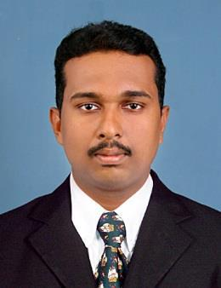

ASWANTH
Email ID: - aswanth.381647@2freemail.com

CAREER OBJECTIVE:

To be a part of company that indulges professional growth which provides challenging and rewarding career while allowing me to utilize my knowledge and skills.

WORK EXPERIENCE

- Sales Executive Aditya Birla Mutual Funds Indian Ltd 05/2017-05/2018
➢ Security Officer Life Insurance corporation of India | 06/2016-01/2017

ACADEMIC QUALIFICATIONS

- BA HISTORY 2014-2017(Completed) SN College Thiruvananthapuram, India

- 12th Govt : Higher Secondary School Pirappancode, 2012-2014
- 10th Govt :Vocational Higher Secondary School Pirappancode
2012

STRENGTHS:

- Work with positive attitude to contribute the healthy functioning for the organization.

- Self-confidence and great patience

- .Willingness to learn.

- Analyzing every angle of the project before working on it.

- Adaptability to change environment.

- Overcome pressure situations

ADDITIONAL SKILLS

Proficient in the following

- MS OFFICE Applications(Word, Power Point Excel)

PERSONAL PROFILE:
Date of Birth | : |  | 30/07/1996
Gender | : |  | Male
Marital Status | : |  | Single
Nationality | : |  | Indian
Languages Known | : |  | English, Malayalam, Tamil & Hindi
Visa Status | : |  | Tourist Visa (Ending 08/08/2018)

