Gerald
Technical Support Assistant
Gerald.381648@2freemail.com

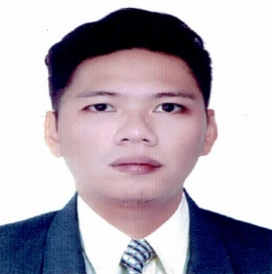

Summary:
Technical Support Assistant
Mobile phone Technician with experience in mobile device assembling; repairing; troubleshooting; and soldering. Knowledgeable in SAMSUNG smartphones and tablets and OPPO smartphones.
Competent on verifying PCB layout in conformity with the schematic diagram. Clean PCB based on standard procedures. Test and visually inspect the functionality of the PCB. Mount and Solder electronic components. Apply soldering and/or de-soldering techniques and procedures. Check soldering products.
Position Desired: Mobile technician.
_____________________________________________________________________________________
Work Experience
SAMSUNG authorized Service Center May 14, 2014 – December 31, 2014
Jan BC Mobile. Mobile phone Technician L1, L2, Chip Level
4th floor, Cyberzone, Mega B,
SM Megamall, Mandaluyong City, Philippines
- Exposure to multiple repair platforms requiring advanced soldering and the use of soldering equipment.
- Provide technical support by trouble-shooting and repairing cell phones and all other devices
- Responsible for getting repair orders done efficiently and in timely manner

Philippine OPPO Mobile September 7, 2015 – May 10, 2018
Technology Corporation Technical Support Assistant L1, L2
Lower G/F, Cyberzone, SM Manila,
Manila City, Philippines
Training attended: Customer service technical training: September 29, 2016
Certified smartphone specialist: August 25, 2017
- Responsible for ensuring customer satisfaction and filling orders
_____________________________________________________________________________________
Cherry Mobile Phone Repair. June, 2018 to September 2018
J20, DAFZA, Dubai, UAE. Iphone refurbishing Company
Iphone 6 to 8s plus
- Performed high quality repairs and refurbishment of electronic devices: phones/tablets/laptops/desktops/servers/ etc.
_____________________________________________________________________________________
Education:
Don Bosco Technical College June 2013 – September 2014
Industrial Electronics Graduate
_____________________________________________________________________________________
Technological College of the Philippines June 2007 – October 2010
Bachelor of Science in Civil Engineering Undergraduate
_____________________________________________________________________________________
Special Skills:
Able to read diagram required for the repair and verify repair maintenance history to avoid taking too much turn around time for the convenience of the customer. Test devices according to the standard procedures. Undertake final quality inspection to avoid repeated repair. Check and diagnose the unit with the use of appropriate technical tools. Check and isolate circuits. Explain and identify faults and explicate it to the

Personal information:
Birth date: August 25, 1990. 27 years old. Weight: 77kg
Height: 178 cm. Body build: Normal
Complexion: Brown

