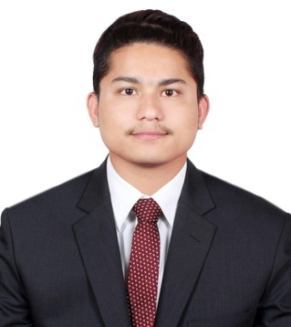
BISHAL
Dubai, UAE
Email : bishal.381654@2freemail.com

Career Objective

A Challenging attractive position commensurate with my qualification and experience. To work in accordance with my knowledge, skills and work effectively by providing high quality & standard service are on my way to the entire satisfaction and success of the company as well as to build up my career and quality.
Work Experience
- 1 year working Experience as a ”Customer Service” in Transguard Group LLC,in Dubai UAE.
- Presently working in Galadari Icecream Company ‘’Baskin Robbins’’ since october 2015 to till date.
Duties and Responsibilities
- Monthly stock taking
- Serving customers to their satisfaction with a smile
- Making daily reports
- Leading my team to reach the monthly set target
- Handling the customer problems in a proper way
- Liaising with managers on how to promote sales
- Handling cash and balancing inventories for the given store
- Order out of stock items in a timely manner
- Manage products returns and exchange
Personal Strength
- Respectful and cooperation with colleagues
- Good Communication Skills.
- Hard working and result oriented.
- Young healthy and energetic.
- Willingness to work effectively and efficiency.
- Can Participate and interact with people from different nationalities.
- Can easily cooperate with staff in any situation
TRAINING SKILLS
- Basic computer knowledge
- Personal incharge certificate from dubai municipality
- Fire fighting
- First aid
Educational & Qualification
- S.L.C- Shree Harikul Model Higher Secondary School in Nepal.
- College – Kathmandu Barsha College
Personal Details
- Gender : Male
- Nationality : Nepalese.
- Place of Birth : Jhapa(Nepal)
- Date of Birth : 31-oct - 1995
- Marital Status : Married
- Religion : Hindu
- Languages Known : English, Hindi , & Nepali.

Passport Details
- Date of Issue : 01-Jun - 2014
- Date of Expiry : 31 – May - 2024
- Place of Issue : Nepal
- Visa Status : Employment Visa.

Declaration
I do hereby declare that all the above mentioned details are true and correct to the best of my knowledge and belief.

