CURRICULUM VITAE.
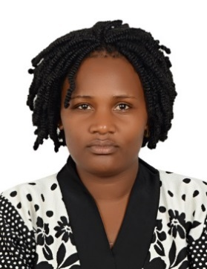
PROFILE INFORMATION.
Name : Aidah
Email : aidah.381674@2freemail.com
Nationality : Ugandan
Date of Birth : 27th Dec 1991
Sex : Female
Marital Status : Married
Visa Status : Visit visa

Position: Waitress/Hostess

CARRIER OBJECTIVES:
To work in a challenging environment as a Waitress where I will be able to provide acquired skills and knowledge

KEY SKILLS:
Customer Service Oriented
Am personable, friendly and always willing to help the customer.
Coordinated and Multitasking
I can do many physical tasks such as carry trays of food and multiple drinks. Am able to do these things while taking orders from new tables, putting orders in to the kitchen and cashing out customers.
Tolerant and Patient
My tolerance and patience skills helped me deal with customers and the hectic environment of a running busy restaurant. For example if I have a rude customer, I must be able to tolerate him and put a smile on my face. Another example is working together with the other workers including the cooks, hostesses and managers as between these areas I expect mix ups but not allow mistakes to deter me from my customers.
Memorization
I wrote down orders, remembered additional customer requests, faces to go with orders, drinks for each customer and the restaurant's menu and specials. I further took a task of learning and memorizing customers’ names.

WORK EXPERIENCE

COMPANY NAME: SHERATON HOTELS UGANDA (FEB 2015 – DEC 2017)

POSITION HELD: WAITRESS

DUTIES AND RESPONSIBILITIES

- Welcoming and greeting customers with a smile
- Escorting customers to their tables
- Giving out menus and taking their orders
- Delivering customer’s food and drinks as ordered
- Checking with customers to see if they are enjoying food
- Handling customer questions and ensuring customers get right answers
- Dealing with bill payments
- Receiving incoming and outgoing calls
- Clean tables after customers have finished dining
- Greet incoming and departing Guests warmly with a genuine smile and eye contact; escort them to assigned dining area; present menus; announce waiter's name
- Use visual cues to seat Guests in either the bar or dining area depending on their preference
- Inform Guest of current promotion and who will be serving them to ensure a smooth handoff to the service staff
- Answer incoming calls to the restaurant and provide appropriate service
- Manage the flow of Guests into the Dining and Bar areas, provide accurate wait times to incoming Guests if appropriate
- Tend to special Guest needs and requests

ACADEMIC QUALIFICATION

• Uganda Certificate of Education (U.C.E)
HOBBIES

- Adventure
- Travel
- Socializing.

REFERENCES

Available upon request

