CURRICULUM VITAE
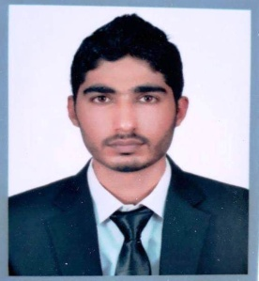
Arslan
Email: arslan.381677@2freemail.com

Position: HOUSEKEEPING AND CLEANING TEAM LEADER
OBJECTIVE:

To improve my skills working on a respectable position, and make my name in the field now I am looking forward for a suitable post in your highly esteemed organization where I can show my capabilities and qualities up to management satisfaction
.
WORK EXPERIENCE:
- Having 2 year work experience as a salesman and customer services in Telenor Pakistan mobile network.

- Having 2 year work experience as a aircraft appearance cleaning team leader in emirates group danata at Dubai international airport.

- Having 2 year work experience as a rent a car supervisor in Makah Kingdome of Saudi Arabia and also have a driving license.

EDUCATION:
- S .S. C (Secondary School Certificate) in Pakistan
- H.S.C. (Higher Secondary Certificate) in Pakistan

PERSONAL DATA:

- Date of Birth : 19/02/1994
- Gender : Male
- Marital status : Unmarried
- Religion : Muslim
- Nationality : Pakistan
- Visa type : visit Visa

Language:

- English , Arabic ,Urdu , Punjabi, Hindi

Qualities:

- Excellent interpersonal and team work skills
- Pleasing personality
- Hardworking, enthusiastic and self motivated
- Friendly, dedicated and can work under pressure
- Object oriented & honest
- A good learner
- Friendly & Pleasing nature.
- I am Punctual & also very well dressed.

DECLARATION:

I sincerely hope that my application will receive your kind attention and I am most anxious that an opportunity for an interview is given to me at your earliest convenience.

REFERENCE:

Reference will be declared in demand.

