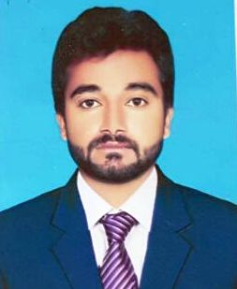
ALI
Email ID: - ali.381686@2freemail.com
DOB: 05-04-1992

Career Objective:
Seeking a Challenging and Rewarding Career, Where my Strong Work ethic, Education and Expertise can be used to help Promote the Mission and exceed team Goals.

Qualifications:
- Metric Passed from Gujranwala Pakistan.
- Diploma in Mechanical Engineering from Lahore Pakistan in 2014.

Work Experience:

Quality Controller - Pak Precise Pvt Ltd (From 01-01-2015 to 31-05-2016)
- Inspect raw materials to ensure consistency and integrity
- Maintain, test and troubleshoot all instrumentation devices
- Attempt repairs on broken or damaged products to determine the best way to scale those repairs
- Test a certain percentage of all products based on industry standards
- Report problems or concerns to senior management immediately
- Manage our quality assurance division and ensure all employees meet their required quotas
- Provide training and support to QA team
- Create an effective, efficient testing protocol to be used across all product lines
Quality Controller and CNC Machine Operator - Master PPRC, Pakistan (From 01-06-2016 to 30-04-2018)
- Read and understand blueprints and specifications
- Monitor or observe operations to ensure that they meet production standards
- Recommend adjustments to the process or assembly
- Inspect, test, or measure materials or products being produced
- Measure products with rulers, calipers, gauges, or micrometers
- Accept or reject finished items
- Remove all products and materials that fail to meet specifications
- Discuss inspection results with those responsible for products
- Report inspection and test data

Professional Courses:
- Diploma in Microsoft Office 2007 & 2010 (Word, Excel, PowerPoint and others)
- Diploma in CNC Machining Center for 3 Month
- Diploma in Auto Cad for 3 Month

Languages:
English, Hindi, Punjabi

Personal Information:
Marital Status : Single Nationality : Pakistani
Visa Status : Visit Visa (Expiring on 11-08-2018)

