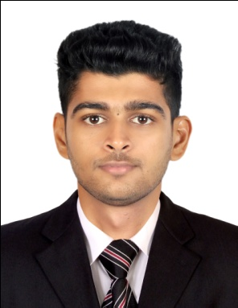

WASIL

Civil Engineer

Email: wasil.381689@2freemail.com

PROFESSIONAL SUMMARY
To secure a position related to my chosen profession where I can exercise professionally the technical knowledge,experience, skills and qualification I acquired during my career.

EXPERIENCE

- SPAN-NEW ASSOCIATES, KANNUR, INDIA Apr’17- Feb’18
Worked as a Site Engineer and Autocad Draftsman .

- BHAVANA BUILDING DESIGNERS, KANNUR, INDIA Jan’15 –Oct ‘16
Site Engineer
Responsibilities:
- Supervision of Site construction activities and executing the work as per the drawings and specification
- Evaluation of measurements of invoices claimed by sub-contractors.
- Day-to-day management of the site, including supervising and monitoring the site labour force and the work of any subcontractors.
- Setting out, leveling and surveying the site.
- Checking plans, drawings and quantities for accuracy of calculations.
- Ensuring that all materials used and work performed are as per specifications.
- Planning the work and efficiently organizing the plant and site facilities in order to meet agreed deadlines.
- Overseeing quality control and health and safety matters on site.
- Maintaining the quality of the work at site
EDUCATIONAL BACKGROUND

- Bachelor of Technology in Civil Engineering;
Mahatma Gandhi University,Kottayam, Kerala ,India (2010-2014)

PERSONAL SKILLS
- Good skills in drawing and plan making.
- Willingness to work in team and a hard worker.
- Ability to deal with people dramatically.
- Excellent analytical and quantitative skills.

COMPUTER SKILLS

- AutoCAD
- ArchiCAD
- STAAD Pro
- MS Excel
- Basic Computer Knowledge

PERSONAL DATA

Date of Birth : 4th of October, 1992
Civil Status : Single
Religion : Muslim
Nationality : Indian

Language : English,Malayalam,Hindi,Tamil, Arabic

