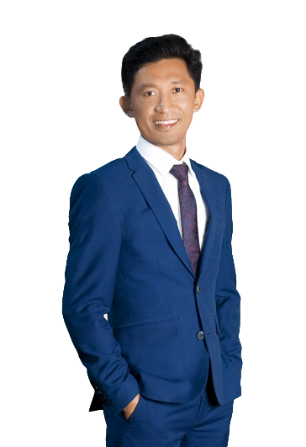

I am looking for a role where I can help make a real impact in the engineering field and ready to make the next step into a career building role. As such I would like to work for an organization where I can be given the opportunity to expend my knowledge of the theoretical knowledge of mechanical automotive and apply it to real life situations. If given a chance, with my time at your company, I can deliver new vibe, energy, and thinking in another perception.

F: facebook.com/Meor Khairur Rijal

Follow me

**Email**

automobile service advisor

**MEOR**

About me

experience

[Meor.381692@2freemail.com](mailto:Meor.381692@2freemail.com)

Tuah Progresif Sdn. Bhd.

(Construction Company)

May 2013 – March 2018

Project Manager

* Monitors contractors work for compliance with schedule, budget, quality, safety and overall conformance with the contract documents.
* Coordinates subcontractors and the construction to meet contractual conditions of performance.
* Prepare external and internal reports relating to job status, daily progress, estimates and deliverables.
* Communicate with the responsible parties to ensure quality construction exceeds company standard and proper industry techniques and processes are utilized, while ensuring the client’s needs and wants are efficiently met.
* Review projects on a daily basis to ensure quality construction standards exits and estimates remain within budget.
* Supervise construction projects to ensure they are completed on time and exceed the customer’s requirements.

FR Vision Sdn. Bhd.

(Printing & Advertising Company)

Production Manager

May 2010 – March 2018

Skills

* Supervising the production staff, ensuring safety standards compliance, improving efficiency and process, checking product specifications and meeting client requirements.
* Manage multiple printing projects simultaneously ensuring quality standards and delivery schedules are met with minimum or no cost over runs.
* Planned and directed the scheduling, processing and traffic of advertising and other creative projects in line with client specification, budget and established deadlines.
* Managed project specifications, billing and estimates interfacing daily with suppliers, clients, account and creative team.
* Increased in-house printing jobs to reduce high-cost outsourced projects.

**Professional Skills**

MS Word

MS Excel

Photoshop

SketchUp

Adobe Illustrator

**Personal Skills**

Puspakom Sdn. Bhd.

(Malaysian Computerized Vehicle Inspection Company)

Vehicle Examiner

Creativity

* Perform vehicle inspection in compliance to the Act, Standard Procedures and Rules & Regulations.
* Inspects truck accessories, air lines and electric circuits, and report needed repairs.
* Examines vehicles for damage, and test drives vehicle to detect malfunctions.
* Tests vehicle components for wear, damage, or improper adjustment, using mechanical or electrical devices.
* Applies inspection sticker to vehicles that pass inspection, and rejection sticker to vehicles that fail.
* Prepares report on each vehicle for follow-up action by owner or police.
* Prepares and keeps record of vehicles delivered.
* Ensure all equipment and tools for inspection purposes are in good conditions and well maintained.

July 2006 – April 2010

Personality

Teamwork

Management

Hard Work

LANGUAGES

English

Malay

* Carry out maintenance schedule service mainly major, express service and major repairs.
* Carry out major diagnosis repair and VOR (vehicle of road) repairing.
* Ensure all vehicle worked on and properly handle.
* Ensure that quality workmanship delivered.
* Ensure and maintain company assets given in a good condition.
* Ensure the safety are followed according to the standard operating procedure.
* Execute and implement any job assignment and instruction by supervisor.

Dec 2003 – June 2006

3S Service Centre

Technician

Motorsport / Playing Football / Traveling / Watching Movie

Hobbies

2nd Grade

Technical School Ipoh, Perak, Malaysia

CGPA : 3.49

Polytechnic of Ungku Omar, Perak, Malaysia

Polytechnic of Kota Bharu, Kelantan, Malaysia

CGPA : 3.35

1997 - 1998

Higher SecondaryExamination

1999 - 2001

Certificate ofMechanical Automotive

Engineering

2002 - 2003

Diploma of

Mechanical Automotive

Engineering

Education