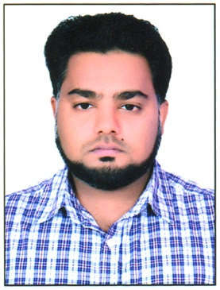
CURRICULUM VITAE
ABDUL

Email: - abdul.381709@2freemail.com

OBJECTIVE:
My objective is to achieve perfection in my work through the process of constant learning, hard work & vision combining with self-motivation contributing the best to the organization.
EDUCATION QUALIFICATION:
- High School from U.P. Board (N.L.G.I.C) Aligarh, in 2007 with 63.33%
- Intermediate from U.P. Board (N.L.G.I.C) Aligarh, in 2010 with 54.41%
- B.Tech from Dr. A.P.J. Technical University Lucknow (U.P.T.U) in 2015 with 67%.
EXPERIENCE:
3 years working experience as a Site Engineer (Civil Construction work) in Radiant construction company (RCC) Noida Uttar Pradesh on role 01/03/2015 to 12/04/2018.
WORK DONE:
- Co-ordinate with the Management to understand the requirement.
- Designed various forms and modules.
- Proposed several Process Improvement strategies and worked on implementing them efficiently.
FINAL YEAR PROJECT DETAILS:
Name:- Building construction pioneer and urban land and infrastructure.
(Supervision for building layout & Civil Construction)
OTHER ACTIVITIES:
- NIIT@ school program during the Academic year 2002-2003.
- Everonn system India Limited computer awareness programme passed the Requisite Exam in Session 2009-2010.
TRAINING:
- One Month training from Harduaganj Thermal Power Station, Kasimpur Aligarh.
TECHNICAL SKILLS:
- Programming Languages: C3 Net 2.0, ASP. Net 2.0, SQL 2000.
- Operating System: Windows.
- Database: SQL
- Basic Computer Skills: MS- Office Internet
- Hardware: Format PC, Software Installation, Solving Basic Problem of Hardware and Networking.
STRENGTH:
- People Management
- Technical Writing
- Complete work at time
- Supervision for construction work
- Behavior smoothly for every person
PERSONAL DETAILS:
Date of Birth : 20th March 1991
Nationality : Indian
Gender : Male
Language Known : English, Hindi & Urdu
Marital Status : Married

