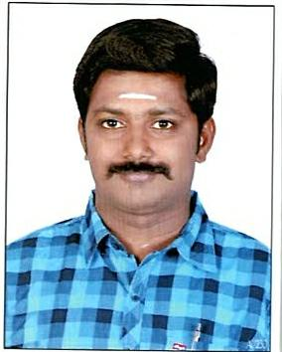
RANJITH

Email: ranjith.381710@2freemail.com

CAREEROBJECTIVE

Toadoptagoodpositioninthechalengingenvironmentandtofurnishmyabilities

andcapabilitiestothereputedconcernandalsomakeuseofalmyopportunitiesingood

manner.

EDUCATIONALQUALIFICATION

- INDUSTRIALTRAININGINSTITUTE(ITI)atTamilNaduIndustrialTraining Center(July2007)MMV(motormechanicvehicles)inIndia

- SSLCatErodewith53%(April2005)inIndia

EXPERIENCE

- WorkedasMechanicatSreeSakthiCareinErodefor1year

- WorkedasTechnicianatAR.A.S&P.V.P.V.Motors(P)Ltd(HYUNDAI)Erodefor 1year

- WorkedasTechnician(MARUTIONROADSERVICE)atSREESARADHAMBAL AUTOMOBILES(P)LTD.,Erode–3Years

- WorkedasTechnicalAdvisorinSREESARADHAMBALAUTOMOBILES(P)LTD (MARUTI)AtErode–3years

- WorkedasFloorco–ordinatorinSREESARADHAMBALAUTOMOBILES(P) LTD(MARUTI)AtErode–1year

- WorkedasSupervisorinSREESARADHAMBALAUTOMOBILES(P)LTD (MARUTI)AtErode–3years

- WorkingasaCalTaxiDriverinDubaiTaxiinDubai

CERTIFICATECOURSE

- StateLevelYoungEmployeeTrainingForCarDrivingAndMaintainsAtErode For3Months(2007)

- ITESENGINEERING&VOCATIONALEXAM BOARDMumbaiasaAutomobile Mechanicat2Month(2007)

- NATIONAL CERTIFICATE IN MODULAR EMPLOYABLE SKILLS as Basic AutomotiveServicing(4Wheelers)at2010

DRIVINGLICENSEDETAILS

Valid(Dubai)UAELightVehicleDrivingLicense(3)

(Automaticandmanual)

ExpiryDate | : | 20.12.2019
PlaceofIssue | : | Dubai

PERSONALPARTICULARS

Dateofbirth :01.05.1988

Languagesknown :Tamil,English

VisaType :EmploymentVisa

DECLARATION

Iherebydeclarethatabovegiveninformationistruetobestofmyknowledge

