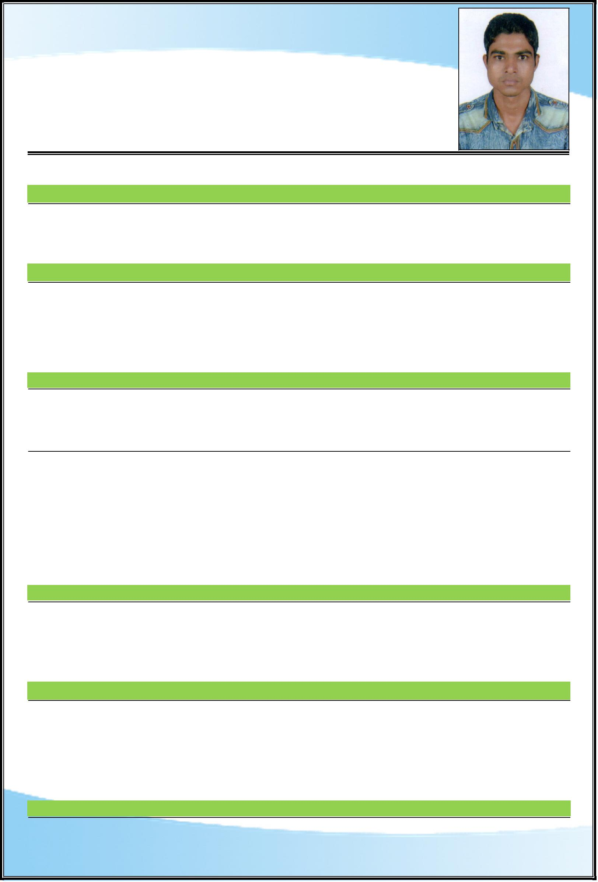
CURRICULUM VITAE

ADIL
Adil.381730@2freemail.com

Dubai, UAE

E-Mail :

POST APPLIED FOR: AC TECHNICIAN

ToCarenhanceerObjective:acareer that tests my professional abilities, add value and make an attempt to achieve organization and individual goals, also to further enhance my skills through learning
Work Experience:
and meet the challenges in any giving chance.
➢ | Presently working as a |  |  | AC Technician with Khansaheb Civil Engineering LLC in Dubai,
➢ | U.A.E since 20.07.2017 to till date.
 | Worked as a Ac Technician in Neumann Aircon Service for the Period from April 2008 to
➢ | October 2012.
Educational Qualification:
 | Worked as a Ac Technician in Carecool Service for the period from November 2012 to October 2014.
 | ❖ | Academic | : |  | Intermediate Passed.
 | ❖
Personal Details: |  |  | : |  | AC Technician Course Certificate, Trade Test Certificate.
 |  | Professional
Date of Birth |  |  |  |  | : | 01.01.1989
Gender |  |  |  |  | : | Male
Religion |  |  |  |  | : | Islam
Marital Status |  |  |  |  | : | Married
Nationality |  |  |  |  | : | Indian
 |  | Details: |  |  | : | English & Hindi
Languages Known
Date of Issue |  |  |  |  | : | 07.04.2015
Date of Expiry |  |  |  |  | : | 06.04.2025
Place of Issue |  |  |  |  | : | Lucknow, India
Pers |  | nal Skills: |  |  | : | Employment Visa
Visa Status
➢ | To maintain good public relation.
➢
➢ | Excellent planning and organization skills.
➢ | Excellent communication skills.
➢ | Honest & sincere in dealing with customer and colleagues.
➢ | Interested to take responsibilities and extra task.
Sincere and Honest.

IDeclarationherebydeclare that the above furnished information is true & correct to the best of knowledge & belief.

ADIL

