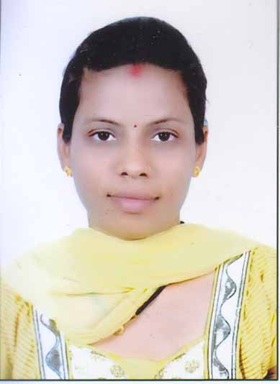
GAYATRI
E-mail: gayatri.381756@2freemail.com
Address: Dubai, U.A.E
Position Applying for: Any Suitable Post

OBJECTIVE
To pursue a career that will give me the opportunity to fulfill my ambition, acquire the training and experience necessary for professional and personal growth, to be able to share my competent, skills, Knowledge, hard work and discipline in company.
SKILLS AND ABILITIES

- Self motivating and able to motivate other as well
- Has the initiative and able to work under pressure
- Ability to recognized or schedule task while being sensitive to time constraint and resource availability

PERSONAL INFORMATION

Date of Birth : 30/05/1992
Place of Birth : Bhaisaya Nagain, Madhya Pradesh
Sex : Female
Civil Status : Married
Nationality : Indian
Visa Status : Visit Visa
Language : English & Hindi

Education attainment

- Bachelor of Arts – Vikram University – India
- Post Graduate Diploma in Computer Applications – Makhanlal Chaturvedi National University of Journalism and Communication, Bhopal – India
- Master of Social works (MSW) Certificated.
- Electronic Mechanic Diploma - ITI
- Higher Secondary School Certificate Passed – Govt. Girls High School – India
- Secondary School Certificate Passed – Govt. Girls High School – India

