PERSONAL DETAILS
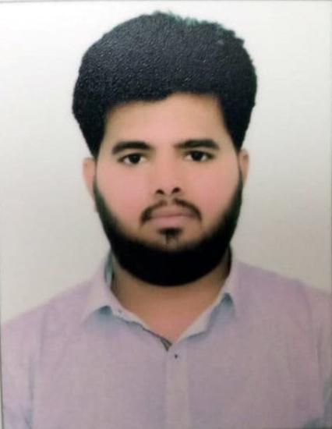
Jay
Age: 23,
Marital status: single,
Gender: male,
Date of Birth: 31/01/1995
Hobbies: Traveling, Music, Food, Cricket.
E-Mail: jay.381764@2freemail.com
~ Education ~

- Sunrise University, Bsc Chemistry (DL), 2014-2017, Score - 67.8%%
- Sheth C.M High School, Gandhinagar, Completed my HSC, 2012 (GSHSEB) Score - 52,8%
- Sheth C.M High School, Gandhinagar, Completed my SSC, 2010 (GSEB) Score - 85,38%
~ Employment History ~
- Sept 2015 - February 2018; Worked as a Team leader in Customer Support up til Feb 2018 at J. K. Infosys.
- Setting an example for the team in achievement of their goals.
- Giving directions and instruction to the team as and when required.
- Filing of sales report on daily basis.
- Setting targets for individuals as per their skills.
~ General Skills ~
- Key Skills, Core Competencies & Strengths - Organizational and management skills, Excellent time management, Motivational skills.
- Concerning for Communication Skills; Confident, articulate, and professional speaking abilities. Empathic listener and persuasive speaker.
- Good judgment to perform given initiative with committed deadline · Strength proven at times- Ability to perform well with little to no supervision.
~ Technical Skills ~

- Data analysis - Good at collecting, organising and interpreting company data, familiar with microsoft Office package.
- Some experience of coding in basic html language, with good typing speed.
- Project management: Good in planning, directing and executing the tasks necessary for a successful project.
- Highly trustworthy, discreet and ethical.
- Capable of multitasking and adapting to fast-paced and changing environment.
- Can operate Microsoft office suite fluently.
- Good accounting knowledge and can operate Tally.
All information stated above in this document is true to the best of my knowledge and belief

