PASSION
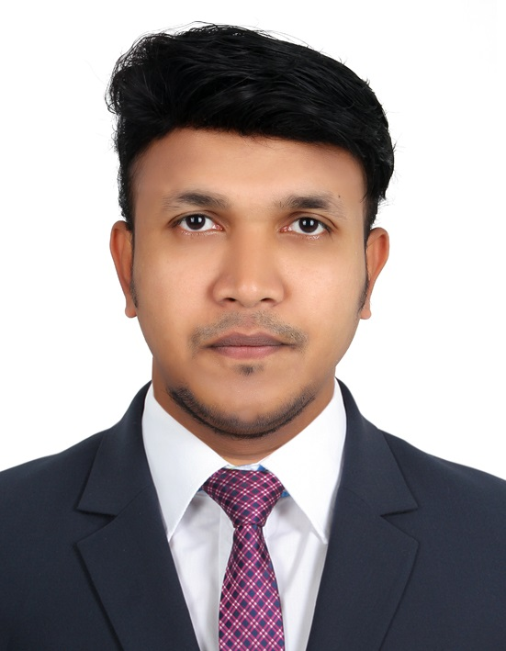

SANDEEP
Personal Profile

DOB: 14/05/1984
Gender : Male
Nationality: Indian
Marital Status: Single

Contact Details

Sandeep.381765@2freemail.com

Languages Known

English, Hindi, Malayalam
& Tamil

Passport Details

Date of Issue: 13/08/2009
Date of Expiry: 12/08/2019
Place of Issue :Trivandrum

Visa Status

Employment visa
Transferable

Enthusiastically seeking a challenging and leading position in a demanding and task oriented organization, which would allow me to utilize my skills and capabilities in a strategic, innovative and analytical way.
PROFESSIONAL ACHIEVEMENTS
MBA(hrm) stream from BharathiyarUniversity 2018(result waiting)
MCOM (finance) steam from Mahatma Gandhi University.2010 MBA (Finance & Marketing) Mahatma GandhiUniversity.2008
BCOM (Computer Application in Business) MG University.2005

TECHNICAL SKILLS

Diploma in Computer Science &Engineering (2yrs-com)
Certificate in Tax practioner.
Diploma in Financial Accounting (MS Office+Tally certification.)
Certificate in Peach Tree Accounting (Grade’A')
Certificate in Office Assistant Course.(OAC) (Grade 'A')

PROFILE IN BRIEF

Project Trainings from NTPC & IRE LTD, the top central govt. companies.
- 6 months Tax practioner training.
- Result oriented and self starter with experience.
- Learn quickly and able to work under pressure.
- Energetic & self-motivated with a high degree of commitment to the job assigned.
- Able to deal the persons diplomatically.
EMPLOYMENT HISTORY IN UAE
AL Razouki Intl Exchange is the one of the leading exchange in UAE. Mainly dealing Bank transfer , money transfer sending and receiving ,Forex ,Salary payroll,, Mobile recharging ,Credit card payment ,etc.
5 year and 10 months more than experience in ARIECO handling different role viz, (15 sept 2012 onwards )
- Preparation of various accounts ie. making cash sheet , tally various MT product, arranging cash in transist .
- Doing supervisory level work for the branch.
- Marketing and convincing different product of the company ,
- As a main cashier handling various nations currencies buy and sell in bulk and small . preparation of salary payroll of different companies
- While HO , in accounts department handle money product reconciliation, money accounts of branches etc product, complaints ,funding of various money product, dealing INR rate with branches, general
- Ensuring and providing best customer services
- Best performance award from MCB bank & six times from eztop

_{DECLARATION}
I hereby declare that above mentioned are true and correct to the best of my knowledge and belief.

