`

RIZWAN
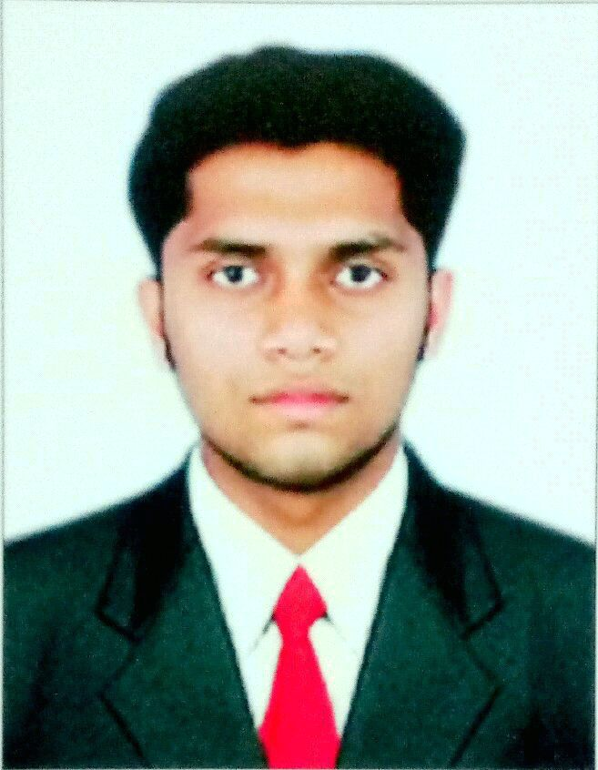
B. E MECHANICAL
Email: rizwan.381775@2freemail.com

Personal Data:

Date of Birth : 05/09/1994

Age : 23

Sex : Male

Nationality : Indian

Marital Status : Single

Hobbies:

Watching News, Browsing Net, watching sports, Reading Newspaper

Languages known:

English, Arabic, Hindi and Malayalam

Passport Details:

Place of issue : kozhikode
Date of issue : 17/07/2014
Date of expiry : 16/07/2024
RESUME
CAREER OBJECTIVES

To secure a challenging position, where I can effectively contribute my resourceful experience and academic skills to the organizational operations

EDUCATION

B.E MECHANICAL ENGINEERING
From Visvesvaraya Technological University Belagavi

TECHNICAL SKILLS

- Proficient in MS-office
- AutoCAD
- Creo Parametric
- Ansys Workbench
- GD&T

INTER PERSONAL SKILLS

- Ability to work co-operatively with the team to accomplish assigned goals, ability to learn and adapt to new technologies and techniques

- Good communication

- Punctual, Hardworking and dedicated to my work

- Ability to deal with people diplomatically

- Fast learner of new skills

- Good Presentation skills

AREA OF INTEREST

- Manufacturing

- Production

- All technical field

OTHER CERTIFICATES

  - CMC Academy

  - Nandi Mahindra
BASIC ACADEMIC CREDENTIALS

Educational | Institution | Board/University | Year of | Mark
Qualification |  |  | Passing | %
BE- mechanical | Dr.S.M College of engineering | Visvesvaraya
 |  | Technological | 2016 | 65
Engineering | Bangalore(Dr SMCE)
 |  | University(VTU)
HSE | Indian School Fujairah, UAE | Board of Higher Secondary | 2012 | 85
 |  | Examinations Kerala
 | Indian School Fujairah, UAE | Board of Public | 2010 | 85
S.S.L.C |  | Examinations Kerala

TECHNICAL QUALIFICATION

- Completed Automobile professional training program in “Mahindra Pride School” Bangalore
- Completed Design professional in Product Design and Analysis at “Cadd Centre” Bangalore
EXPERIENCE

I worked as Technical Trainee in Maruti Suzuki India Limited, Bengaluru, Karnataka, India
from Oct 2016-Oct 2017
PROJECT

- FINAL YEAR PROJECT: “A Study on the Road Power Generation Using Sliding Mechanism for Obtaining Electricity”
ACHIEVEMENTS

- Secured 2nd in 800mts Race during 12th std school sports
- Became House prefect during 11th std
- Secured 3rd in 200mts Race during 9th STD school sports
DECLARATION

I hereby declare that all the information furnished above is true to the best of my knowledge and belief

RIZWAN

