Ahsan  E-MAIL: ahsan.381781@2freemail.com  VISIT VISA | 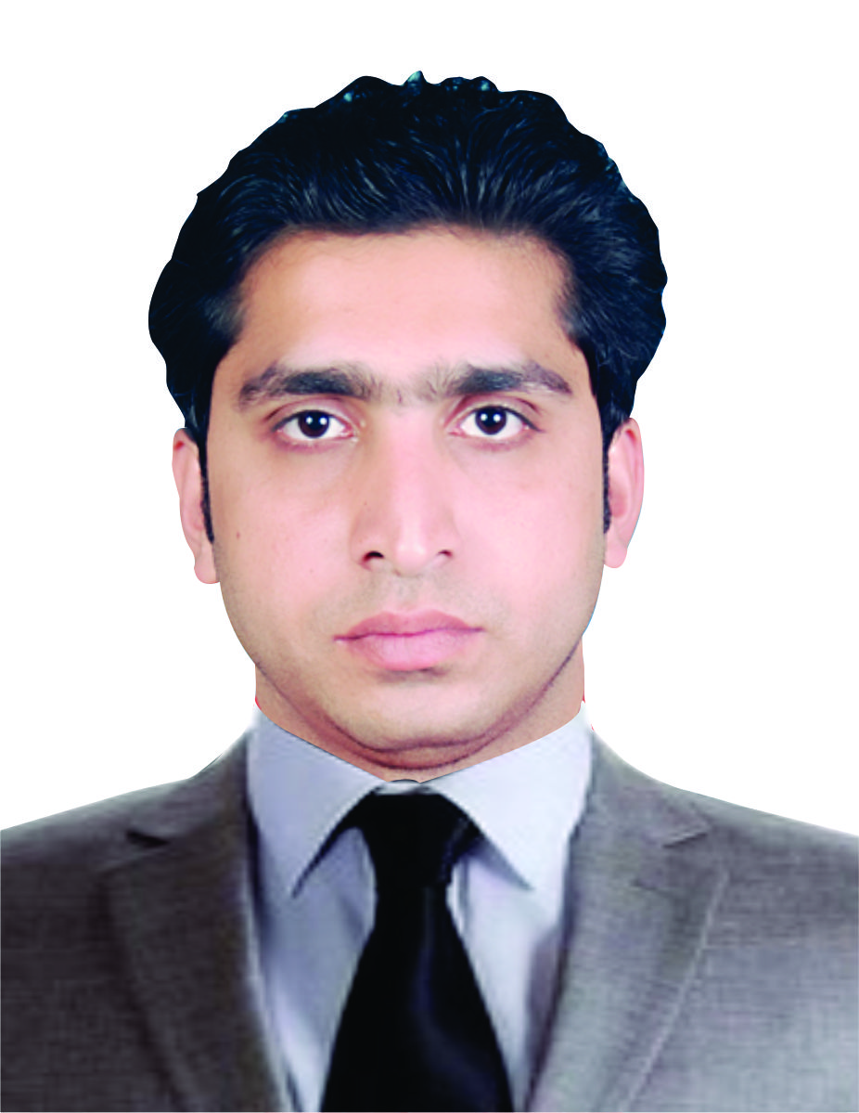

Career  Objective | Looking for Accounting or Finance job to revamp my career in a corporate setting which encourages learning and growth. The organization in which my long term career enhancement is possible and for which I can be a strategic fit in value creation process, is the ideal organizational setup I intend to work in.
Job  Experience  Responsibilities  Job  Experience  Responsibilities  Job  Experience  Responsibilities  Job  Experience  Responsibilities  Professional  Qualification  Strengths and  Skills  IT Skills  Personal  Info  Languages  Reference | AL JAMAHEER AL ARABIAH KITCHEN (SHARJAH) UAE.  17 MAY ACTIVITY OF ACCOUNTANTS  • Quotation prepare  • Prepare cheque for Payment  - Salary Sheet Prepare  - Daily Attendance Sheet Maintain  - Tax working preparation (VAT)  - Prepare Income Statement / Cash flow statement  For report to higher Authority Management  - Inventory Control / Cash Handling  ACCOUNTS OFFICER AT TOTAL TECHNOLOGIES (PVT) LTD.  (PAKISTAN) MAY 2017 to MARCH 2018  - Travelling & Daily Allowance Branch Expenses prepare  - Prepare & posting journal and cash payment voucher  - Prepare & posting of Receipt and Bank payment voucher  - Bank Guarantee & Advance Remittance  - Salary Sheet Prepare and Enrollment of all Employee  - Cash handling  COMPUTER OPERATOR AT EASY TYPINNG & DOCUMENT CLEARING L.L.C (UAE)  JAN-,2017 To APRIL-2017  - Quotation / Document prepare  - Salary Sheet Prepare and transfer for company  - Cash handling  ASSISTANT ACCOUNTS OFFICER AT GENETICS PHARMAEUTICALS (PVT) LTD PAKISTAN  Aug-,2015 To Jan-2017  • Prepare of Bank Reconciliation Statement at the end of Month.  • Prepare of vendor and customer Reconciliation Statement  • Invoice posting & Prepare expenses sheet according to  Accounting policy.  • Maintaining daily transaction  - BACHELOR OF COMMERCE (2013)  PUNJAB UNIVERSITY OF LAHORE  - Knowledge of supplies, equipment and services ordering and inventory control  - Ability to reconcile stock counts to report data  - Analyzing and Problem solving Ability  - Strong work ethic and ability to interact well with the people at various level within the organization  - Peachtree /MS Office /other Accounting software  Shorthand and good typing speed  - Email, Internet, & Web Browsing applications  Nationality: Pakistani  Date Of Birth: 12-01-1989  Religion: Islam  Marital Status: Single  English & Urdu.  Will be furnished on demand.

