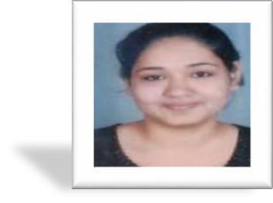
Name: Sejal
Email: sejal.381782@2freemail.com

Visa Status: Visit Visa

Visa Expiry: 30th Sep 2018

Objectives

Goal oriented and highly analytical professional in Finance & Accounting with +3 years of experience in the industry looking for an opportunity in an organization where I can utilize my expertise and improve our experience within the organization.

Professional Skills

- Good theoretical knowledge of laws

- Excellent knowledge of accounting and auditing laws
- Very well versed with MS-Excel

- Can work efficiently in Tally (All versions)
- Good at quick arithmetic calculation

- Good command over accounting

WORK EXPERIENCE

Organization | Designation | Duration
ND Patel & Company | Article Assistance | Aug’14–to Aug’2017

Responsibilities:

- Income Tax

- Preparation of Computation of Income and Income Tax Returns for Various kinds of assesses

- Preparation of submissions against notices received from the income-tax authorities during the assessment and appeal proceedings

- Proficient in preparation of various Summaries such as sales, purchase working capital, etc.
- Projecting tax liability and calculation of advance tax payable
- Tax audits for Private Companies, individuals and firms

- TDS compliance
- Statutory Audit

- Statutory audit of Private Limited companies engaged in trading and manufacturing businesses

- Vat Audit

1

Computer Skills

- Completed 100 hours of compulsory computer training specified by ICAI

- Taxation and TDS Software Known: Winman
- Operating System: Microsoft Windows 7, XP, 10
- Utilities: Ms Office, Accounting Package – Tally 4.5, 7, 9, ERP

Interpersonal Skills

- Good oral communication skills
- Can work for a long period

- Manage the stressed condition
- Problem solver
- Multitasking ability

Academic Qualification

 | EXAM | BOARD/UNIVERSITY | PASSING YEAR
 | C.A. | Institute of Chartered Accountant of India | Pursuing
 | B.Com | University of Mumbai | 2014
 | H.S.C | Maharashtra board | 2011
 | S.S.C. | Maharashtra board | 2009

 |  | Personal Details
Date of Birth | : | 21.11.1993
Gender | : | Female
Marital Status | : | Single
Nationality | : | Indian
Languages | : | English, Hindi and Gujrati

2

