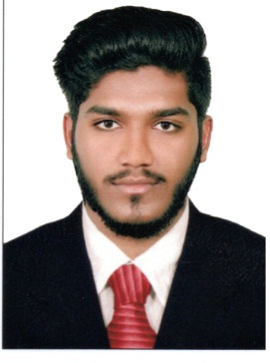
THANSEEH

EMAIL : thanseeh.381799@2freemail.com

PERSONAL PROFILE

Date of birth : 18-10-1997
Gender : Male
Marital Status : Single
Nationality : Indian
Language Known : Malayalam, English & Hindi

OBJECTIVE

Looking forward for a position in a leading organization where I am able to apply the knowledge gained through my degree and work experience. I firmly believe in the principle of implementing my duties with dedication and determination. I am looking for good career growth opportunities where my talent and knowledge could be best subjected and utilized for the benefit of the organization and myself

EDUCATIONAL QUALIFICATIONS
- Plus Two
Subject : Commerce
Board : Kerala High Secondary
Institution : BTMHSS Thurayur
Year of Pass : 2016
- SSLC
Board : Gov. of Kerala General Education Department
Institution : GVHSS Payyoli ,Kozhikode
Year of Pass : 2014

ADDITIONAL QUALIFICATION

- DEPLOMA in Industrial Safety Engineering March 2017
- NEBOSH(course completed)
- IOSH
- HABC
- RISK ASSESMENT
- INTERNAL AUDITING
- MEDIC FIRSTAID
EXPERIENCE

- Telecom Technician at AL RASHIDIYA COMPUTERS Dubai
Experience:
  - Cable pulling end to end ( structured cabling )
  - Key stone jack termination
  - Rack setting in server room
  - Cable dressingin the server room
  - Patch panel patching in the rack

KEY STRENGTH

Ability towork sincerely and accurately, with good communication skills.

DECLARATION

I hereby declare that the above mentioned information is correct up to my knowledge and here the responsibility for the correctness of the above mentioned particulars.

