CURRICULUM VITAE

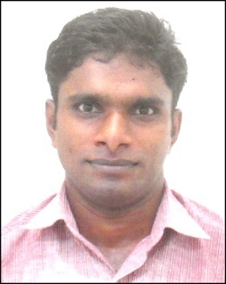
Mr. Joseph

E-Mail: joseph.381816@2freemail.com

MY PROFESSIONAL OBJECTIVES
I am looking forward to be a part of esteemed organization which will provide me a good exposure in whatever task I have been assigned with and utilize my capability, knowledge and experience for the betterment of my own career and the development of organization.
PROFESSIONAL QUALIFICATION
1. One Year Diploma in Hotel and Restaurant Services
2. Three Year Diploma in Computer Engineering
3. Mechanic Motor Vehicle (2 Year) Industrial Training institute

ACADEMIC PROFILE

10th | 2000 | Board of Public Examinations Kerala
12th | 2000-2002 | Board of Higher Secondary Examinations Kerala

AREA OF INTEREST

Food and Beverage Services.

STRENGTHS:

- Hard working
- Ability to work
• Honest
- Quick learner

INDUSTRIAL EXPERIENCE
- Presently Working as Restaurant Captain in Foodbook Restaurant UAE from 7thSeptember 2016
- Worked as Restaurant Captain in Queens Restaurant Muscat Oman 10th November 2014 to 3rd March 2016

- Worked as Guest Service Associate in HMSHOST India Services Ltd
At Bangalore International Airport 22nd January 2013 to 31 August 2014
- Worked as a Trainee Waiter in Novotel Singapore Clarke Quay from 9thApril 2012 to 8thOctober 2012.
- Worked as a Part Time Waiter in Le-Tonkin French &Vietnamese Singapore from 1st November 2011 to 30th September 2012.
4. Worked at Emirose Management Services as Asst. Manager from 30thAugust 2010 to 30thJuly 2011
5. Worked at Emirose Management Services as Marketing Executive from 9th January 2006 to 31st July 2007
6. Worked at Procter & Gamble Home Products Ltd as Trainee from 1st November 2004 to 30th November 2005
My objective is to become a successful man and well known person, always update my knowledge for better performance.
PERSONAL PROFILE
Date of Birth: 01-05-1985
Gender: Male
Marital Status: Single
Languages Known: Malayalam,English, Hindi and Tamil
Nationality: Indian

DECLARATION

I do hereby declare that the above declarations made by me are true according to my knowledge and belief any discrepancy in this regard will be subjected to me only.

