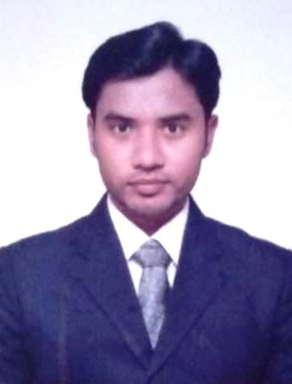
SHABBIR
Email: shabbir.381823@2freemail.com

Objective
To pursue a growth oriented career in HR with a progressive company that provide a scope to apply my knowledge and skills that would help me contribute my best to the organization.

Skills/Competencies Developed:

2+ yrs. Qualitative Experience in HR with premier companies in India.
- A well-organized individual contributor in End-to-End HR functions.
- Supporting and managing the management as Associate HR.
- Strong experience in HR generalist activities.
- Proficient with Microsoft Office, Excel, Outlook.
- Experience of working in fast paced high-pressure environment.
- An effective good communication skills and interpersonal skills.
- Hands-on experience in Man power Management, Team Building, Team Management, Vendor Management, Training & Development and Grievance Handling.
- Excellent track record of HR Operations for Permanent, Contractual & Contract to reduce manpower attrition.

Professional Experience
Worked as Associate HR in Metro Cash &Carry india.pvt.ltd from April 2017 to December 2017.
Worked as Assistant HR in Avenue Super marts Ltd (D-Mart) from November 2015 to March 2017.

Roles and Responsibilities:
- Operating Value Moves, Attendance management System (AMS), Employee Self Service (ESS) & MIS.
- Answering a multiline telephone system.
- Updating various Excel spreadsheets for employee benefits and various companies’ related spreadsheets.
- Process new employees through the company orientation program which includes company rules, regulation, culture, etc.
- Maintaining personal files of employees and documentation.
- Coordinating bankers for opening new joined bank accounts.
- Handling leave records and attendance in system with the HR manager.
- Explaining the policies, procedures, benefits, and what will be expected from them as new employees.
- Making sure that every employee is aware of safety procedures before they start work at the facility.
- Processed the weekly garnishments and payroll deductions.
- Conducting employee engagement activities.
- Generating ESI numbers.
- Handled Full and Final Settlements and Exit Formalities.

Achievements
- Won the regional best HR in 2017.
- Reduce attrition from 16% to 3%.
- Developed an absolute transparent culture among the employees and HR.

One month project work:
- One month project at CCL (Continental Coffee Ltd) in the field of HR on the topic “Training and development”.
- Participated in motivational training.
- New employee induction training.

Education
MBA in HR & Marketing from JNTUK in 2015.
B.Sc. Computers and Electronics from Acharya Nagarjuna University in 2013
Technical Skills
- Certified in Diploma In Computer Applications.
- MS Office.
Personal Details
Date of Birth : 06-03-1992
Gender : Male
Marital Status : Single
Nationality : Indian
Visa Status : Visit Visa
Languages Known : English, Hindi, Urdu & Telugu.

