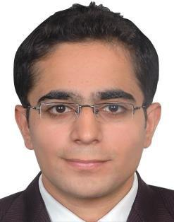
AKUL
Customer Service Representative with India Experience

D.O.B.: 20-Jan-1990
Nationality: Indian

Location: Dubai, UAE

Email: akul.381826@2freemail.com

PROFILE

Akul Puri is an accomplished Customer Service Representative with 7 years of experience as a Customer Service Representative. He has proven success in organizing tasks, satisfying customers & is searching for a service industry where his experience and skills would be put in use.

OBJECTIVE

Applying 7 years of Indian Customer Service Representative experience combined with proven expertise in resolving customer queries.

EDUCATION

IHM, Mumbai, Maharashtra, India

B. Sc. in Hospitality & Hotel Administration 2010

LANGUAGES

English – Excellent reading, writing and speaking

Hindi – Excellent reading, writing and speaking

SPECIALIZED SKILLS

- Excellent interpersonal and communication skills

- Multi-tasking abilities with proficiency in organizing and managing different tasks

- Self motivated, devoted and decisive management personnel

- Having excellent time management skills & determined in accomplishing set matters

- Have ability to adapt to new responsibilities

- Efficient in general office functions

PROFESSIONAL EXPERIENCE

Customer Service Representative, Admiral Solutions [EUI Ltd India Branch Office]

(2017-2018)

Admiral Solutions is one of UK's top 3 car insurers with an annual turnover of £2.12 billion

Responsibilities and Role details:

- Research and answer clients’ and underwriters’ calls

- Advise clients regarding insurance coverage and risk management issues

- Process insurance policy changes, renewals and cancellations

- Foster and maintain good working relationships with clients, insurance company underwriters

Travel Service Consultant, Yatra.com (2012-2016)

Yatra.com is an Indian online travel agency and a travel search engine based in Gurgaon, India

Responsibilities and Role details:

- Handling post sales queries such as rescheduling and cancellations ,resolved them to ensure customer satisfaction while maintaining first call resolution

Customer Care Executive , CNEB Private Solutions (2010-2012)

CNEB Private Solutions is an Indian BPO based in New Delhi, India

Responsibilities and Role details:

- Delivering the team sales target by generating web leads, coordinating with off site team
  - resolved customer queries and ensured better efficiency at work

VOLUNTEER EXPERIENCE

Food & Beverage service for Emirates Kingdom Flight Catering at Dubai Airshow 2009, UAE

OTHER INTERESTS

Reading novels, watching Youtube videos & movies

THANKS

AKUL

