Abedalqader
Dubai, United Arab Emirates

Email: abdelqader.381830@2freemail.com

Objective:

Secure a responsible position in account management and serve as an account representative sharing my breadth of experience and abilities effecting mutual employee and employer growth and success.

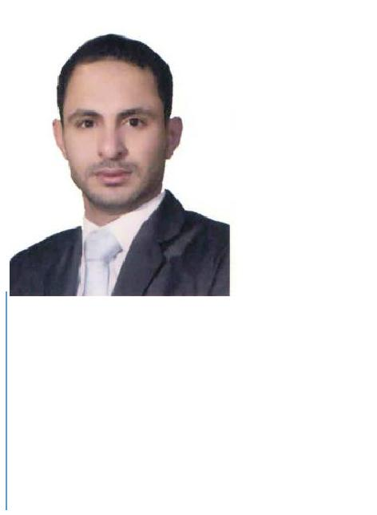

Personal Information

Nationality: Jordanian

Date of birth: July 3rd .1984
Place of birth: Ruseifah -Jordan

Gender: Male

Marital status: Single

WORK EXPERIENCE:

  - Accountant: Freelancer / Amman - Jordan 01/07/2017 - Present

- Following Income & Sales Tax.

- Cost Control for Projects Under construction.

- Work with management in issuing suitable financial policies.

- Preparing required financial reports and ledgers for external auditors, and work with them to issue balance sheet.

- Analyzing financial reports.

- Follow post financial transactions.

- Manage cash flow by tracking transactions and regularly reviewing internal reports

- Following HR Dep. (social security, taxes, and payroll).

    - Chief Accountant: AL-Zer for Constructions/ Amman – Jordan 14/01/2008 – 30/06/2017

  - Follow collecting debits, and update accounts payable and timely payments to suppliers, accounts receivable and issue invoices

  - Posting daily transactions.

  - Monthly reconciliation, and accounts updating.

  - Financial reporting: trial balance, income statement, cash flow, and other required reports.

  - Sharing in budgeting, and forecasting, then follow apply it.

  - Financial analysis, to make a suitable decision.

  - Analyzing financial reports and transactions.

  - Provide professional assistant to employees, projects managers, and control them to apply plans, and company policies.

  - Contribute in sign contracts with external parties.

  - Follow actual cost, and expenses, to be sure that we under the budget.

  - Work with external auditors to issue balance sheet, and prepare required documents for that.

  - Build good relations with external parties like (banks, suppliers, customers) and follow with them financial issues.

  - Audit financial transactions and document accounting control procedures.

  - Assist in developing and documenting business processes and accounting policies to maintain and strengthen internal controls.

  - Following HR dep. (social security, taxes, and payroll).

- Accountant: AL-Rebat Housing Co./ Amman - Jordan 01/03/2007 – 31/12/2007

  - Posting daily financial transactions.

  - Issue cost projects.

  - Monthly settlements and adjustments for accounts.

  - Cooperate with financial manager in issuing final statements

EDUCATION

Diploma in accounting information systems
Arab Community College-Amman, Jordan

COURSES

Practical Accounting (36 Hours) at Injaz Center-Amman (2007)

JCPA (102 Hours) at Injaz Center-Amman (2007)

SKILLS

Computer& Internet | 90 %
Microsoft Office | 90 %
Computerizes Accounting Systems | 90 %
Communications Skills | 90 %
Team Worker; Hard Worker | 90 %
Time Management | 90 %
Ethical & professional attitude | 90 %
Carry Out Administrative Duties | 70 %

LANGUAGES

ARABIC (mother language)

English: Reading, writing and speaking (Good)

REFERENCES: Available upon request

