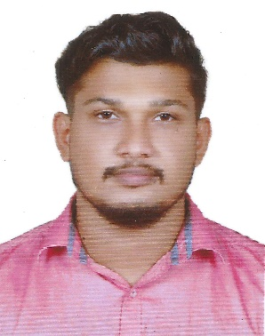
SAJIN
Email: sajin.381834@2freemail.com

CAREER OBJECTIVE
To expertise in the field of Mechanical engineering to achieve excellence in this sector. A career which can sharpen my current skills & knowledge where I can have good scope for learning and implementing new technologies.

ACADEMIC PROFILE:

- M-Tech in Advanced Manufacturing and Mechanical System Design (2015 - 2017) from Gov. College of Engineering Kannur, Kannur, Kerala. KTU (8.43 CGPA)
- B-Tech in Mechanical Engineering (2011-2015) from College of engineering Thalasseri, Kannur, Kerala, CUSAT (69.57%)
- 12th from Seethi Sahib Higher Secondary School, Taliparamba, Kannur, 2011, (93.75%)
- 10th from Tagore Vidyanikethan Govt. HSS, Taliparamba, Kannur, 2009, (95%)

WORK EXPERIENCE:

- Asst. Professor at College of Engineering Thalasseri, Kannur, Kerala (29th August 2017 – 13th April 2018)

ACADEMIC PROJECTS
M-Tech:Finite Element Modelling of Quenching Residual Stress and Residual Stress Evolution During Hole Drilling. Re-distribution of residual stresses during machining can cause geometrical distortion and result in rejection during inspection. In this work, FEM was used to estimate the residual stress generated in a rectangular block during quenching and then the re-distribution of residual stress during hole drilling operation. An experiment was also proposed to validate the FEM results.
B-Tech: Design of Shell and Tube heat exchanger for refinery applications. Designed a heat exchanger which can be used in refineries. With improved heat transfer efficiency and lower pressure drop. The higher efficiency was obtained by replacing ordinary baffles by helical baffles.
SOFTWARE SKILLS:
- AUTO CAD
- ABAQUS
- ANSYS
PERSONAL STRENGTH
- Takes initiative and works in independently or a part of group
- Ability to learn and adapt.
- Innovative, Hardworking, Ability to analyze problem/issues.
PERSONAL DETAILS:

Date of Birth : 23-08-1993
Nationality : Indian
Sex : Male
Marital Status : Single
Languages Known : English, Malayalam & Hindi
Hobby : Swimming, reading

DECLARATION
I hereby state that all details furnished above are true to the best of my knowledge and understanding.

