CURRICULUM VITAE

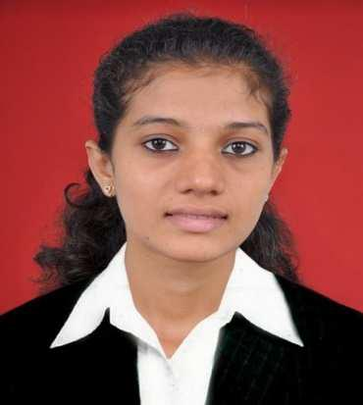
Preema
Preema.381862@2freemail.com

- Date of Birth: 4th April 1997
- Sex : Female

- Marital Status: Married

- Nationality: Indian

- Visa Status: Visit visa

Career Objectives:

Recent accounting graduate looking for a position in accounting and finance. where I can utilize my skills, put my learning into practice and contribute. I am eager to learn and excited about beginning my career in this dynamic industry.

Key Skills:

Communication and teamwork able to communicate effectively in a professional business manner and as a member of a team. Strong written and verbal communication skills acquired through study and work. Ability to meet deadlines and work under pressure Enthusiastic, hard-working and eager to learn Reliable and trustworthy, with a strong work ethic and values.

Educational Details:

- DCA (Diploma in computer applications) Manipal University

 | Major: Tally ERP 9.0 & Microsoft | 2018

- Bachelor of Commerce Mangalore University
Major: Accounting; Tax (GST & IT)

Minor: Management

Graduated with 82% | 2015 - 2018

- Pre-University Education (12th) (EBASC) Sri Mahaveera Pre-University college

Graduated with 86.86% | 2013 - 2015

• SSLC (10TH)
Lourds High School
Passed with 74.88% | 2010 - 2013

Computer Skills:

- Microsoft Office 2010 (Excel, Access, Word, PowerPoint) with some experience with Tally ERP 9.0

Language skills:

- Fluent in spoken and written English, Hindi, Kannada.

I hereby declare that the information provided above is true and accurate to the best of my knowledge.

.

