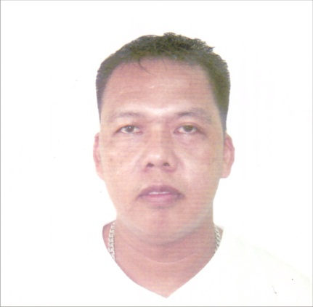
Carlos
E-mail address: carlos.381864@2freemail.com
PERSONAL BACKROUND
Age​​​: 41
Height​​​: 5’10’
Weight​​​: 90 kg
Birth Date​​: August 22, 1976
Birthplace ​​: Cebu City, Philippines
Gender​​: Male
Civil Status​​: Married
Citizenship​​: Filipino
WORK EXPERIENCE
Security Officer/Security Guard
CAT Security Group
Convergys BPO
August 2016 - August 2018​
Security Guard
Megamatrix Security Agency
City Savings Bank
December 2015 - July 2016
Lead Guard
Teyseer Security Service
Cultural Village Project - Katara
Doha, Qatar
September 2014 - September 2015​
Security Guard
SS7 Security Agency
360 Pharmacies
APRIL 2013 - June 2014
Security Officer/Security Guard Reliever
Philand Security Agency
Union Bank - Philippines
February 2013 - April 2013
House Detective/In-House Officer
CACAI Security Agency
Amisa Hotel and Residence
August 2012 - January 2013​
Security Officer / Shift In-Charge
Genghis Khan Security Agency
Robinson’s Mall
October 2011 - May 2012
Machine Operator
Pejana’s Machine Shop
October 2009 - April 2011
Production Operator
Liquid Puree Department
Ranritch Agency & Services
Profoods International Corporation
September 2004 – September 2005
Property Custodian
Property Supplies Department
Metro Gaisano Ayala
July 2000 - December 2000​
TRAININGS ATTENDED
Safety Officer Construction Occupational Safety and Health Training
Mariner’s Court
March 6, 2017 - March 10, 2017​
Security Officer Basic Security Supervisory Course
Valiant Security Training Center
February 6, 2012 - February 13, 2013
Security Guard Refresher Training Course (NC II)
Lancer Security Trg. Center
August 17, 2011 - August 24, 2011​
Security Guard Pre-Licensing Training Course (NCI)
Centurion Security Agency Training Center
July 5, 2004 – July 29, 2004​
EDUCATIONAL BACKGROUND
Bachelor of Science in Customs Administration
University of Cebu
June 1995 - October 1998
Machine Technology
Don Bosco Training Center - Pasil
January – December 1994
Secondary Education
Gothong National High School
June 1989 – March 1993
Preliminary Education
Pasil Elementary School
June 1983 - March1989

