Date of Birth:

November 28th, 1989

Gender:

Male

Marital Status:

Single

Religion:

Islam

Nationality:

Pakistani

E.mail: Furqan.381871@2freemail.com

Furqan

Career Objective:

To obtain a challenging career oriented position in an organization where my education and experience be further enhanced and my skills and potential would make a significant contribution to the institutional development as well my professional growth.

Education and Qualifications:

- Enrolled for CPIM
▪ | Iqra University - Karachi | 2017
 | MBA (Supply Chain Management)
▪ | Karachi University | 2010
 | B.Com
▪  S.M Govt Science College, Karachi |  | 2007
 | Intermediate (Pre- Engineering)
▪  Dua High School, Clifton, Karachi |  | 2005
 | Matric (Computer Science)

Professional Experience:

March 1th 2014 till Aug 31st 2016
AEG Travel Services (Pvt.) Ltd

Holiday’s Planner

- Sales Coordinator Frequent Individual Travelers.

- Organizing Over all travelling tour of Business Executives.

- Taking quotations from international and local vendors, negotiating with them and taking care of financial activities.

- Maintaining relationship with firms and supporting Travel desks in firms.

- Reviewing contracts and renewal on basis of current market environment. USA Consulate Karachi

- Worked as US visa Facilitator at US Consulate Karachi. German Consulate Karachi
- Worked as German visa Facilitator at German Consulate Karachi.

Projects and Reports:

- Project report on procurement cycle of coke, ERP system of procurement cycle of coke, planning of materials, Demand Planning, E-Sourcing, Procurement, Contract Management, Supplier/Vendor Relationship Management, Negotiation, Material/Service Research Analysis.
- Research done on logistics of meat in Karachi.

- Thesis submitted on POTENTIAL OF OUTSOURCING MAINTENANCE, REPAIR AND OPERATION (MRO) ITEMS TO IMPROVE PROFITABILITY OF FMCG SECTOR

- Project report on Industry analysis of Hero Honda India.

- Project report on performance management on the basis of variances

- Project report on work force diversity.

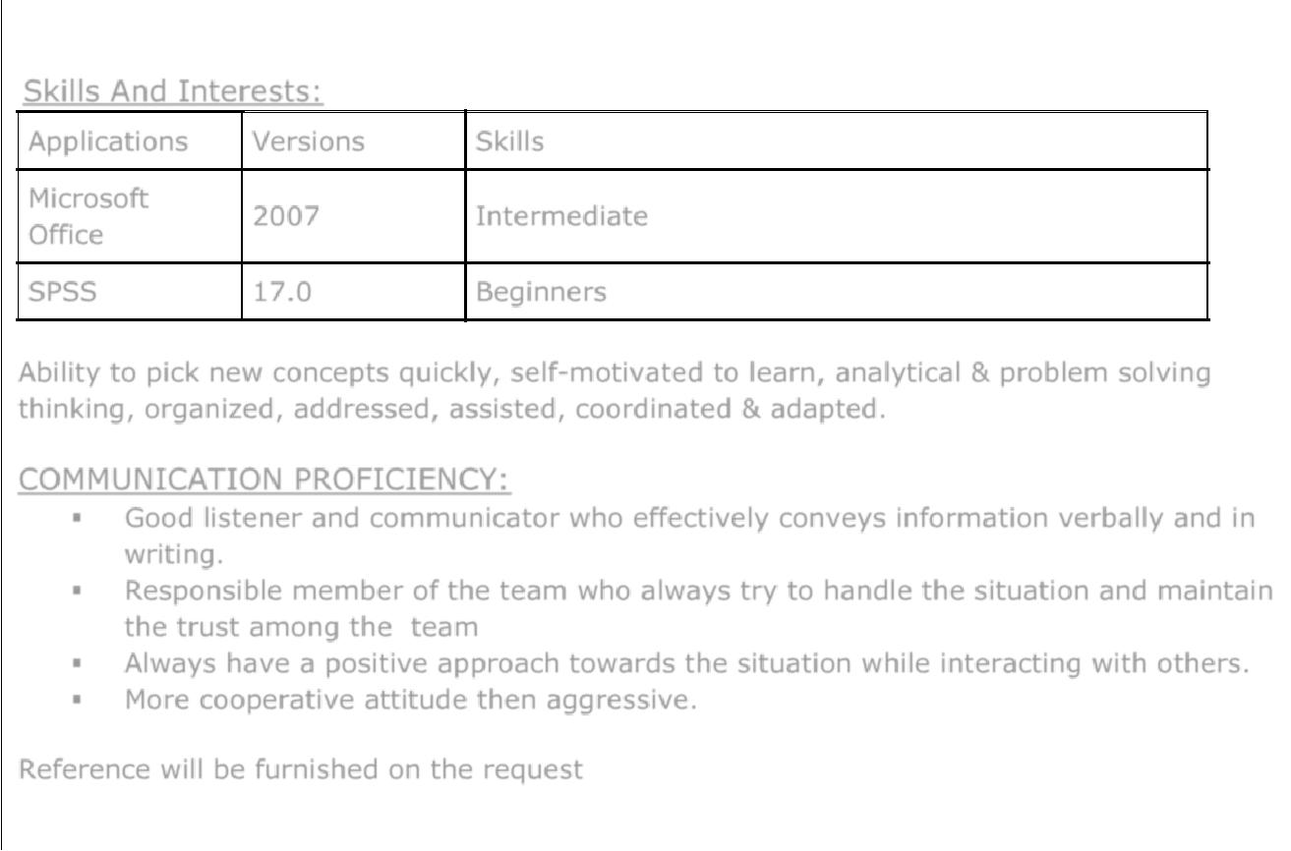

Skills And Interests:

Applications

Microsoft

Office

SPSS

Versions Skills

2007 Intermediate

17.0 Beginners

Ability to pick new concepts quickly, self-motivated to learn, analytical & problem solving thinking, organized, addressed, assisted, coordinated & adapted.

COMMUNICATION PROFICIENCY:

- Good listener and communicator who effectively conveys information verbally and in writing.

- Responsible member of the team who always try to handle the situation and maintain the trust among the team

- Always have a positive approach towards the situation while interacting with others.

- More cooperative attitude then aggressive.

Reference will be furnished on the request

