S A L A H E L D I N

PERSONAL INFORMATION

Marital status : Married.

Nationality : Egyptian.

Age : 49

Military Status : Exempted.

E M A I L : salaheldin.381910@2freemail.com
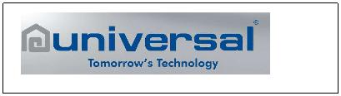

November, 01, 2017 – Present (Universal Gas Cooker Company).

Engineering Factories Manager (Gas Cooker).

Evaluating Factories operation systems & teams in order to define all the gaps and start the developing Plans.

Work with Factories managers teams to define KPI’s per each manager at each factory activity (All Production Departments & Planning & Maintenance & Die Workshops & follow up & Internal transportation managers).

Start a monthly KPI presentation meeting for each factory manager to Company chairman & his assistant to show the factories positive & Negative progress.

May, 11, 2017 – October, 19, 2017 (Abdulaziz Alsorayai Company).
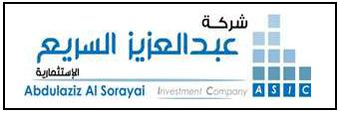

Factory Manager.

Evaluating Factory operation system & team in order to define all the gaps and start the developing Plans.

Start a Global action plan all over factory departments.

Define KPI’s for each managerial position in the factory (Production & Maintenance & Foreign & Local Purchasing managers).

Work with top management and all the team to pass the hard economic situation of the company during the economic circus over the Saudi country.

Studying open more business fields for the factory in the Saudi market "study investing in Led lights applications which can be suitable for Saudi market".

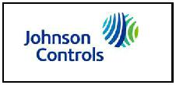
May, 01, 2010 – May, 09, 2017 (Johnson Controls – AL-Salem York) Company.

Operation Manager.

Evaluating the current operation system in order to define all the gaps and start the developing Plans.

Start a Global action plan all over factory departments “Presentation files are available for the actions done per each department in the factory”.

Re arrange the Factory resources update the organization structure for the whole factory Operations.

Start defining the 2011 KPI’s for the Production Manager & Maintenance Manager & Departments Heads using Johnson controls system “GPAS”.

Develop a global action plan to improve the handling over the AHU “Air Handling Units”, RTU “Roof Top Units” lines, Coils and start daily mechanism for daily productivity calculations per workshops.

Start a global project to connect the important Factory machines through PLC and network to measure machine utilization every hour with full record for every stoppage with Cooperation of JCI team at USA.
Start a project to put all the factory shop floor under a Camera monitoring from all the supervision, safety and management teams on 24 hour to guarantee the shop floor efficiency and safety.

Share in the QFB competition of all JCI factories and won the best Practice prizes for two consecutively years.

Study and develop the factory layout with adding two extra AHU lines, which facilitate a flexible manufacturing through Assembly lines and reduce the factory lead time.

Start Projects with Global C.I. Department, Production and Quality teams to implement Lean Manufacturing on the factory and also some Kaizen Events to reduce the Waste “June 2012”.

Start Projects with C.I. Departments through all the factory departments to start a yearly saving of 1.2 million $ during 2012 and increase year over year “March 2012 till now”.

Start the GES survey, collect the yearly results and work with the team to develop the internal customer satisfaction.

Start Project to build new factory, work with the team to study the flow and work to develop the layout as per the latest technology & Standards in the field of Air Conditioning, including new machines & Equipment selections.

Lead & Work with the team towards establishing new products in the factory through the partnership of JCI (Chillers & Fan Coil & ….. etc).

Lead & Work with the team to apply the JCMS “Johnson Control Manufacturing System” latest technology leaded by JCI in the field of production development and waste elimination.

Achieve Level 2 of JCMS at Sept., 2016 and new target raised by the JCI president to work towards level 3 by June 2016

Team member with Quality & Production engineers on leak & Brazing improvement project in the factory.

December, 01, 2009 – April, 30, 2010 Naloo - Company.

Factory General Manager.

Evaluating the current operating system in order to define all the gaps and start the developing Plan.

Develop a Global action list for all the factory departments to monitor the development progress and actions implementation.
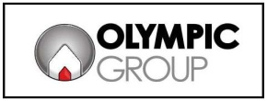

December, 02, 2008 – November, 30, 2009 Olympic Group (Water Heater factory)

Production Operation Manager.

Manage all Production & Maintenance Departments managers in an organization size of more than 900 workers and employee.

Evaluating the current operating system in order to define all the gaps and start the developing Plans, Then start a Global actions plan all over factory departments.

Define the yearly KPI’s for the whole teams and supporting them towards achieving the company goals.
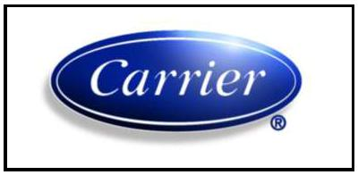

March, 01 - November 30, 2008 Miraco - Carrier (Abu Rawash factory)

Manufacturing Engineering Manager.

Team member in cost reduction team schedule B for 2008 (total no. of projects included are 36 projects).

Coordinate moving ACE program form the manufacturing to quality department to renew the bronze qualification before end of 2008.

Head of a team which Travel to Italy to Receive and inspect a mass Spectro meter machine for coils leak detection “the manufacturer name Galileo”, the total machine cost around 168,000 Euro (march 2008).

Head of a team which travel to Michigan, USA to receive and inspect a fin pres and hairpin bending machine with a cost of 1.1 m$ (June 2008).

Head of a team which Travel to Italy to Receive and inspect a CNC tube bending machine for commercial units, the total machine cost around 115,000 Euro (July 2008).

Head of a team which travel to Michigan, USA to receive and inspect a Mechanical expanding machine with a cost of 0.260 m$ (August 2008).

Team member in the new Carrier factory in Egypt, share with the team in the layout design of the new factory to cover the production increase demand in the next 10 years.

Team member in organizing a Shingi Kaizen event in Egypt in the period from Oct. 26 to 31, this event was leaded a Japanese Sensi “Mr. Nagata” and Carrier vice president for manufacturing “Mr. Bill Sch.”

Oct., 01, 2004 – Feb., 2008 Miraco-Carrier (Abu Rawash factory)
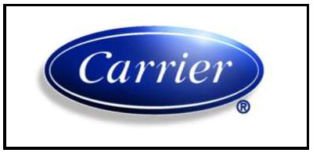

Manufacturing Engineering & ACE Program Manager.

Team member in cost reduction team (Starting at October 2004).

Coordinate applying ACE program and assessment for seven business Cells (achieve the qualification level at Nov. 2004).

Support the HR Department to Achieve the ACE Bronze level ay July 2005.

Support Miraco Financial Department to Achieve the Qualification level at July 2005.

Support Carrier Africa & Miraco Export to Achieve the Qualification level at Sept. 2005. “By this achievement Miraco has become fully Qualified”, 2005.

Support 13 Manufacturing Cells to Achieve Bronze level at December 2005.

Travel to Spain to study the manufacturing steps of commercial units technology transfer project (Dec. 10 – 17, 2005).

Travel to Malaysia to receive a hard die sets for sheet metal of new console model (Jan. 20 – 27, 2006). Travel to Czech to attend the ACE conference course (Jan. 30 to Feb. 05, and 2006).

Travel to Europe to inspect a mass Spectro meter machine and to Finland to visit T-Drill factory (June 6 – 10, 2006).

Travel to five cities in China for a new Suppliers qualifications plan (June 20 to July 02, 2006). Travel to UAE to attend a meeting related to the new ACE criteria (Sept. 12 to 14, 2006).
Organize an ITO university training session (March 2007).

ITO university professor and certified assessor for ACE Program.

Organize internal kaizen event under the support of Carrier world head quarter. (March 2007). Lead internal assessment for ACE program bronze level. (May 2007).
Support and team member of Shingi Kaizen event under the leadership of the Japanese expert (Sensi) Mr. Takahra and under support of Carrier world head quarter. (August, 2007)

Owner of internal LPG network project for Miraco factory (March: September 2007).

Select and put the specifications of a complete fin line from burr oak company in USA with a project cost around 1.6 M$. (Oct., until finish next Aug. 2008).

Team member in selection of a high accuracy leak-testing machine (mass Spectro meter) “Galileo, Italy”. (Nov. 07 till finish at Feb. 2008).
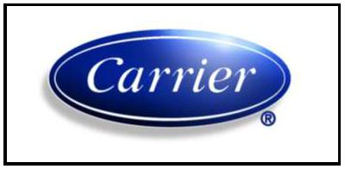

Dec., 2003 – Sept., 30, 2004 Miraco-Carrier (Abu Rawash factory)

ACE Coordinator for all Miraco Departments (Manufacturing & business) + Head of Manufacturing engineer Dept.

Follow and check the running manufacturing B.O.M for 260 models related to all Carrier products and assembly lines.

Follow up all the manufacturing duties related to all Miraco assembly lines + Painting and Wiring workshops, (this means 12 cells out of total 16 cells inside Miraco factory).

Start up building a team to control all manufacturing duties, this team consists of (four Manufacturing engineers + draft + one employee).

Start coordinates applying ACE program for all business process (4 Cells) to achieve the qualification level.

Coordinate applying the ACE program on 16 Manufacturing cells to achieve the bronze level.

Manufacturing representative to deliver the new molds for VMC product from Korea (Jan. 2004). Travel to China to study the modern technology for Air Conditioner Assembly Lines (April 2004). Travel to Italy to study the modern technology for Air Conditioner Assembly Lines (May 2004).

Coordinate with a team from Carrier and UTC for preparation of ITO university training session in Cairo at (May 30 to June 03, 2004).

Make a special study and plan to transfer all Miraco assembly lines to be semi-automatic lines.

Feb., to Dec., 2003 Miraco-Carrier (Abu Rawash factory)

ACE Coordinator + (Commercial and chilled water + Window + Refrigeration) lines Manufacturing engineer.

Start coordinate applying the ACE program on 16 manufacturing cells. Attend special training at Lyon, France for this program.
Achieve the qualification level in the ACE program for the 16 manufacturing cells one month before the plan.

Follow and check the running B.O.M for 43 models related to these three assembly lines. Follow up all the manufacturing duties related to those three assembly lines.
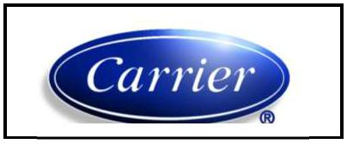

2002 – 2003 Miraco-Carrier (Abu Rawash factory)

PDS Coordinator + (Commercial and chilled water + Window) lines Manufacturing engineer.

Coordinate applying PDS program inside Miraco (attached file for improvements).

Managed the (Commercial and chilled water + Window) production lines from manufacturing site.

Start studies with engineering department for new Condensers for refrigeration units with capacities from 1.5 to 30 hp (low and medium temperature).

Design and execute new line for refrigeration unit’s condensers.

1998 – 2002 Miraco-Carrier (Abu Rawash factory)

Commercial and chilled water area team leader.

Managed the commercial and chilled water production line. Participated in the chilled water design team.
Improved labor productivity by 32 %.

Improved machine productivity by 26 %.

Decrease the scrap percentage to lower than 3 %.

Improved product quality “Factory critical defects” by 17 %. Participated in selection & installation of safety equipment.

1994 – 1998 Miraco – Carrier (10th of Ramadan factory)

Sheet metal fabrication, Painting station manager

Initiated sheet metal, painting station departments at the 10th of Ramadan factory. Prepared department budget reports.

Introduced new sheet metal joining techniques. Participated in launching of ISO 9001 system.

1991 – 1993 Miraco – Carrier (Abu Rawash factory).

Manufacturing engineer

Transferring the sets of drawings to AutoCAD drawings. Prepared process sheets for all kinds of products.

Participated with material teams to improve cutting techniques and scrap factor. Participated in layout of the factory to minimize movements inside the factory.

1991 – 1991 Military factory no. 99 (3 months).

Manufacturing engineer

Participating in the research and development department. Participated in solving some of the production problems.

PROFESIONAL EXPERIENCE

Able to plan, execute and follow-up projects meeting deadlines. Working experience of CNC m/c programming.
Working experience of jig, fixture, die maintenance and selection.

Able to recruit and lead team members in changing environment & increase the productivity. Working experience of preparing and applying quality documentation.
Working experience of Microsoft Windows, word, excels, AutoCAD (2D).

TRAINING COURSES

“Flexible manufacturing systems” (March 25 to April 6, 1995).

“Quality system auditors for ISO 9001” (3 weeks starts from April 26, 1995). “PDS Certified Professional” (1996).

“English for business courses” (1997 to 1998). “Positive leader ship” (March, 15 to 19, 1998). “Design for everything”.
“Setup reduction”.

“Statistical method and process control”.

“Cooling and air conditioning systems” (November 14 to 17, 1999). “Corrosion problems in industry”.

“ITO University” Cairo Sept. 9 to 12, 2000.

“Advanced Course for EH&S Training” Cairo. “PDS Lean Production” (January 2002).

“ACE Training Course” Lyon, France (April 7 to 10, 2003) “ITO university Session” (Cairo 2004).
“ACE Coordinator conference” Lyon, France (March 2005).

“Process Certification Conference” Istanbul – Turkey (July 25, 2005). “Environment Health & Safety Committee” (January 1 to 5, 2006).
“ACE Coordinator conference” Prague, CZE (Feb. 2006).

“Kaizen Event on CDU Cond. & Hi Wall Assembly Lines” (March 7 to 15, 2007). “ITO university Training” (March 2007).

“Shingi Kaizen event on Coils Workshop” (August 2007).

“Leading in the Dynamic Environment” (July 15, 16,17,30,31, 2008). “Shingi Kaizen Event” (October 26 to 31, 2008).
“Stress Management” (May, 26, 2009) – Olympic Group. (Sept., 5, 2010) – Johnson Controls.

(Sept., 11, 2010) – Johnson Controls.

“Safe Start” (Nov., 24, 2010) – Johnson Controls.

“Integrity & Compliance Message Assessment” (Dec., 25, 2010) – Johnson Controls.

(May 5-6, 2011) - Johnson Controls.

(Jan. 31 – Feb., 01, 2011) - Johnson Controls.

“Situational Leadership II Workshop” (March 21 to 26, 2012) - Johnson Controls. “Project Management Preparation” (April 19 to 23, 2015).
Attend about 16 online training courses c.w. Exams covering JCMS “Johnson Controls Manufacturing Systems” in the period from (May till November 2016).

SUMMER TRAINING

Heliopolis co. for housing and development (Electric train sector). The international Arabic company for optics.

EDUCATION

1990 – 1991 Ain Shams university (Faculty of Engineering). B.Sc. Mechanical engineer (Production Department).

Arrangement: The third on the group.

G.P.a. : Very Good.

Project: Application of PC Computer in The Field of Machining (Grade: Excellent).

REFERENCES

References are available upon request.

LANGUAGES

Arabic language is excellent in both spoken and writing. English language is excellent in both spoken and writing.
________________________________________________________________________________________

