CURRICULUM VITAE
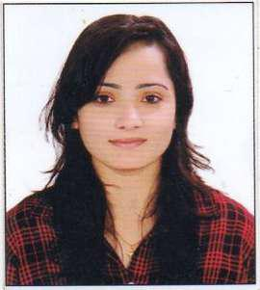

Neha

International City
Dubai - UAE

Visa Status – Sponsored by Husband
Neha.381931@2freemail.com

_____________________________________

OBJECTIVE:

A career opportunity with a reputed technology firm where i can best utilize my technical knowledge and soft skills to learn, grow and add value to the organization.

EXPERIENCE & PROJECT DETAILS:

- Research Paper: - Working on the Concept Hierarchy Extraction from Text Book Published International Journal Paper in (IJCSEDI).
- Car Sales Systems: Application Based on Data Base.
- Teaching Assistantship – D.B.M.S. Prolog, C and C++ in IET DAVV – July 2015 to June 2017

- Worked as Assistant Professor – D.B.M.S., T.O.C., Compiler Design, A.D.A. and Computer Fundamental in MIST Collage (RGTU University). (July 2017 to January 2018).

ACADEMIC PROFILE

- Master of Engineering in computer science branch from IET DAVV, Indore aggregate 8.1 CGPI.

- Bachelor of Engineering in computer science branch from RGPV Bhopal with aggregate 72.18% in year 2012.

- HSC from Pink Flower High Secondary - Indore with 70.6% in year 2005.

- SSC from pink flower high secondary school Indore with 63.55% in year 2007.

ACADEMIC ACHIEVEMENTS

- Cleared Graduate Aptitude Test Exam with good score.

- Certificate for Completion of language C, C++, OOPS from universal informatics.

- Certificate of CCNA

TECHNICAL SKILLS

Subjects of Interest: Math, Science, Hindi, Basic Computer and any Subject depends of requirements.
Knowledge of S.E.O. Digital Marketing, Web Design Programming Languages: C, C++, PHP, SQL Web Technologies: HTML, JAVASCRIPT
Operating System: All Windows environment

PERSONAL STRENGTHS

- Positive Attitude,

- Self-Motivated.

- Team work ability

- Easily adaptable in nature.

EXTRACURRICULAR ACTIVITIES

- Participated in college activity Tarunyyam.

PERSONAL PROFILE

Date of Birth
Nationality
Visa Status
Languages Known
:

: 18 March1990
: Indian
: Family Visa

: English, Hindi, and Urdu

I hereby declare that all details given above are true best of my knowledge and belief.

