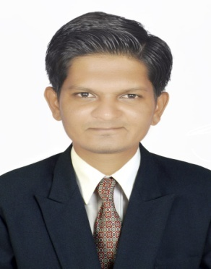
HARDIK
Email ID : hardik.381944@2freemail.com

OBJECTIVE :

Intend to build career with leading corporate of hi-tech environment with committed & dedicated people, which helps to explore myself for the growth of organization.

Profile :

- Ability to work hard and systematic for achievement.
- Goal-oriented individual with strong leadership capabilities.
- Good Communication skills.

Education :

- Bachelor of science(Chemistry) Since 2014 in Gujarat University,
With CGPA 5.12
Gujarat, India
- Higher Secondary Certificate in Science Stream Passing in the year 2011. With 66.14%.
- Diploma Computer Engineering Since 2011 TEB,
With Pass Class
- Secondary School Certificate in General Stream Passing in the year 2007, with 66.15 %.

CAREER EXPERIENCE :

- I worked in R.D. Chemicals Company as a QC–Chemist.
Nadiad (Gujarat, India)
Duration : Dec 2015 To June 2018

Responsibility :

- Inspect, test, and sample materials or assembled parts or products for defects and deviations from specifications.

- Observe and monitor production operations and equipment to ensure conformance to specifications and make or order necessary process or assembly adjustments.
- Discuss inspection results with those responsible for products, and recommend necessary corrective actions.
- Discard or reject products, materials, and equipment not meeting specifications.

SKILLS :
- Chemical Analysis
- Data entry of QC-Analysis report
- PH value by PH meter
- Finish Product Testing

Computer Skills :

- MS Office
- Internet & email

