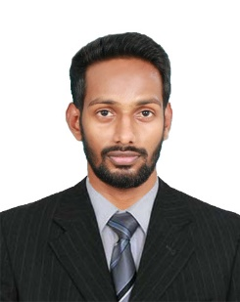
FASAL

Email
:

Fasal.382032@22freemail.com

:

Career Objective

Seeking for the best opportunity, to work in a responsible position and make use of knowledge and skills acquired, for the progress of organization, there by continue to learn and grow professionally.

Professional Experience
- Hindustan Software House, Kerala, India - worked as a Software Developer from November 2016 - November 2017
- GTech Computers, Kerala, India - worked as a Programmer from August
2016 – November 2016

Project at Hindustan Software House
- Mahal Management System:
Developed a Windows form Application for managing different tasks of a mahal and entire transaction. It provides facility to add new Family and Family Members, and Edit the existing family and members details.
- TCNCart:
Developed Online Mart by using Opencart.

Academic Achievements
- B E–Computer Science Engineering from Yenepoya Institute of Technology, affiliated to Visvesaraya Technological University Karnataka, India in 2016.
- Plus Two through CHMKG Higher Secondary School -India, Kerala board in 2009.
- SSLC through PJHS - India, Kerala Board in 2007.

Technical Training & Courses attended
- Workshop for “Ethical Hacking and Cyber Security” conducted by Geeklas Technologies pvt. Ltd at YIT on 27th and 28th October 2015
- Workshop for “Python Programming” conducted by Python Express at Yenepoya Institute of Technology on 13th and 14th February 2016

Technical skills/Knowledge
- Languages : C, JAVA BASICS, PHP, HTML, .NET C#
- Packages : Visual Studio 2010, MS Office, Wordpress, MySQL, OpenCart
- Operating systems : Windows, LINUX, ANDROID

Skills and Strengths
- Competent and confident to deliver diverse responsibilities effectively, be it as a team leader, team player or an independent problem solver.
- Quick to learn new and innovative skills & techniques.
- Ability to adapt to any sort of environment, get along with people
- Build and maintain relationships.
- Ability to learn from experience, Reliable & Responsible.
- Willing to learn, flexible, hardworking, energetic and creative etc.

Personal Information
Age & Date of birth | : 25, January 1990
Religion | : Islam
Gender | : Male
Marital Status | : Single
Nationality | : Indian
Languages known | : English, Malayalam, Tamil, Hindi;
Declaration
I hereby declare that information given above are true and correct to the best of my knowledge and belief wishing for your earlier and positive response

