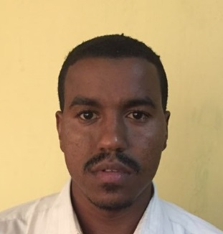
Hussien

Personal information____________________________________________________________
Address: Dubai
Email: hussien.382065@2freemail.com
Nationality: Sudanese
Date of Birth: 18/Nov/1993

Summary_______________________________________________________________________
Electrical power systems engineer with good theoretical understanding and little experience in most of power systems disciplines such as generating stations, electrical wiring, protection systems, power electronic devices, switchgears and motor control units.

Education______________________________________________________________________
B.Sc. (Honours) in Electrical and Electronic Engineering – 2015
Electrical Power Systems Engineering, First Class
University of Khartoum

Work Experience_______________________________________________________________
- Product Support Engineer
Afroscot Services Co. Ltd (Ascot International Agent) – Khartoum, Sudan
Sep 2016 – Jan 2018
Duties and Responsibilities:
- Installation and maintenance of diesel gen-sets
- Design of ATS panels.
- Installation and maintenance of UPS devices.
- Supervision of different projects and preparing all required documents and reports
Projects:
- Installation of 112 diesel generators for SUDATEL Telecommunication Company.
- Installation of 500 KVA diesel generator and 1250 A ATS panel for Bank of Khartoum.

- Electrical Engineer
Elecon for Electrical Services – Khartoum, Sudan
Oct 2015 – Aug 2016
Duties and Responsibilities:
- Assisting in the design of electrical networks schemes, carrying out load flow analysis studies and determining voltage drop performance, thermal loading performance and network losses.
- Preparing schematics for electrical network schemes according to documents and symbol standards and templates.
- Reviewing electrical equipment problems such as power factor correctors and VFDs, and suggest suitable solutions to overcome these problems.

Projects:
- 300 KVAR power factor corrector at Al-Qadarif grain silos: review the working status of the device and suggest the suitable solutions to the problems found.
- Protection scheme at Baleela oil field: implement a coordination scheme between the various parts of the network and calculate the values of current and time limitations to isolate the faulted parts only.
- 33/11 KV Altakamol cement factory substation: member of the consulting staff of the substation.
- Electrical wiring at Rawat Petroleum Operating Company camp: review the current status of the electrical wiring, circuit breakers capacities, cables sizes and diesel generators, draw the single line diagram and suggest the suitable solutions to the problems found.

Skills___________________________________________________________________________
Computer skills:
- Microsoft Office (Word, PowerPoint and Excel).
- MATLAB.
- ETAP.
- AutoCAD.
Languages:
- Arabic: mother tongue.
- English: very good (IELTS score: 6.5).

