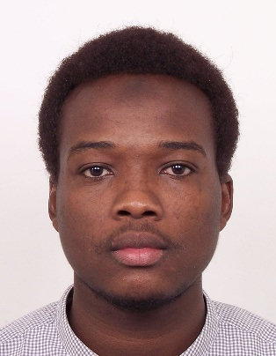
BAKHIT
Email: bakhit.382066@2freemail.com

SUMMARY
An enthusiastic and highly motivated individual with a dream to secure apprenticeship in preparation for professional engineer (PE) backed by; First Class honors from Bachelor of Civil Engineering (HONS), from infrastructure University kuala lumpur.

HIGHLIGHTS
- Able to provide detail design
- Able to provide site supervision
- checking technical designs and drawings to ensure that they are followed correctly
- Critical thinker

- Structural design
- Managing parts of construction projects
- ensuring projects meet agreed specifications, budgets or timescales.
- Infrastructure design

EXPERIENCE
02/2018 – 06/2018 | NCT BUILDING & CIVIL ENGINEERING SDN BHD (Malaysia)  Civil Site Engineer

- Managed and lead workers
- Checked structural drawings before casting
- Prepared site progress Report
- Calculated and ordered concrete mix
- Tracked project progress
03/2017 – 06/2017 | IKRAM CONSULTANTS SDN BHD (Malaysia)  Intern

- Road geometry design
- Research on safety at site
- Technical Report
- Research on axle load

ACHIEVEMENT
- Helped the company to identify risk at site (highway/traffic).
- Helped the company to prepare an ongoing project report to contractors.
- Helped the company to prepare for a seminar presentation.

EDUCATION

09.2014 – 02.2018 INFRASTRUCTURE UNIVERSITY KUALA LUMPUR
Bachelor of Civil Engineering (HONS) – CGPA (3.752)
- Design of Concrete Structures
- Design of Steel and Timber
- Highway Engineering
- Geotechnical Engineering
- Hydraulics and Hydrology
- Project Management
- Finite Element Modelling & Analysis

10.2010 – 08.2013  SKILLS | LYCEE IBNU-CINA  HIGH SCHOOL  - Advance Mathematics  - Physics  - Chemistry
EXPERTISE | COMPUTER AIDED DESIGN  - AUTOCAD  - AUTOCAD CIVIL 3D  - ESTEEM  - ETABS  - STAAD PRO  - ROBOT STRUCTURAL ANALYSIS  - ABAQUS (Finite Element modelling)  INFORMATION TECHNOLOGY  - Microsoft Office  - Microsoft Project  - Prezi
ANTICIPATION | To provide technical support throughout the development phase of any projects and can show strong technical attributes such as liaising with the team in providing details design. Able to monitor and lead the site team for smooth timely task completion according to drawing and specifications as well as establishing a record and maintain a full set of project documentation.

POSITION APPLIED
Civil Engineer

AWARD
- Dean’s List award (2015 & 2016)

