Abubker
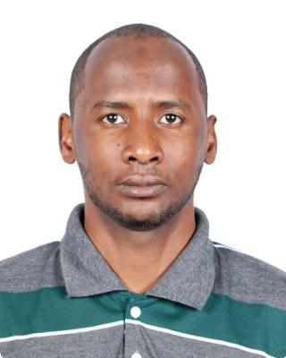

E-mail : abubker.382081@2freemail.com

Work experience

Khartoum police Sep 2008 — Jan 2012

Administrator

System administrator in it department Khartoum police with used Ms office and skills management Internet services skills

Dyee consulting services September 2015 — December 2015

Administrator system

System administrator

Qualifications

MCSE

Strategic planning

Strategic organisation design

Cyber security

Responsive website basics

C and c++ programme

New HR 21st century talent management

Design and build website without code

Introduction to human rights

Grow your audience certificate from YouTube

SAP lumira building data visualisation

Affiliate marketing

CCNA course

Vmware course

Linux administration course

Education

Bca June 2014 — June 2017

University of madras

Ccna

Sunrise institute

1

Interests

Computer and Internet reading books

References

References available upon request.

2

